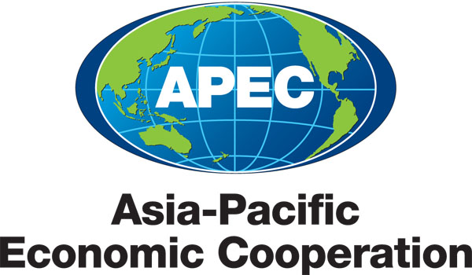
___________________________________________________________________________
2010/SOM3/SCE/000
Agenda Item: 8.5

Document Classification List

Purpose: Consideration

Submitted by: APEC Secretariat

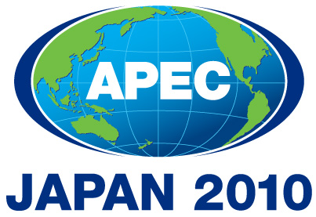 | Third SOM Steering Committee on Economic and Technical Cooperation Meeting  Sendai, Japan  24 September 2010

Document Classification List

Document No. | Title | Agenda Item | Submitted By | Public Release |  | Reason for Restriction | Derestriction Date (where applicable)
 |  |  |  | Yes | No | Reason for Restriction | Derestriction Date (where applicable)
2010/SOM3/SCE/000 | Document Classification List - Third SOM Steering Committee on Economic and Technical Cooperation Meeting 2010 | 8.5 | APEC Secretariat |  | √ | Internal document
2010/SOM3/SCE/001 | Draft Annotated Agenda - Third SOM Steering Committee on Economic and Technical Cooperation Meeting 2010 | 2 | SCE Chair | √
2010/SOM3/SCE/002 | Improving the SOM Steering Committee on Economic and Technical Cooperation (SCE) – Committee of the Whole (COW) | 3.1 | SCE Chair |  | √
2010/SOM3/SCE/003rev1 | Implementation of Streamlining SOM Steering Committee on Economic and Technical Cooperation (SCE) Sub-Fora | 3.1 | SCE Vice Chair |  | √
2010/SOM3/SCE/004 | Project Management Report | 3.3 | APEC Secretariat | √
2010/SOM3/SCE/005 | APEC Project Quality Criteria | 3.3 | APEC Secretariat | √
2010/SOM3/SCE/006 | Energy Working Group (EWG) Medium Term Workplan | 3.5 | EWG LS | √
2010/SOM3/SCE/007 | Gender Focal Point Network (GFPN) Medium Term Workplan | 3.5 | GFPN LS |  | √
2010/SOM3/SCE/008 | Telecommunications and Information Working Group (TEL) Medium Term Workplan | 3.5 | TEL LS | √
2010/SOM3/SCE/009 | Transportation Working Group (TPTWG) Medium Term Workplan | 3.5 | TPTWG LS | √
2010/SOM3/SCE/010 | Counter-Terrorism Task Force (CTTF) Medium Term Workplan | 3.5 | CTTF Chair | √
2010/SOM3/SCE/011 | Mining Task Force (MTF) Medium Term Workplan | 3.5 | MTF Chair |  | √
2010/SOM3/SCE/012 | Emergency Preparedness Working Group (EPWG) Workplan | 3.5 | EPWG Co-Chairs |  | √
2010/SOM3/SCE/013 | Small and Medium Enterprises Working Group (SMEWG) Medium Term Workplan | 3.5 | SMEWG LS | √
2010/SOM3/SCE/014 | Agricultural Technical Cooperation Working Group (ATCWG) Medium Term Workplan | 3.5 | ATCWG LS |  | √
2010/SOM3/SCE/015 | Fisheries Working Group (FWG) Medium Term Workplan | 3.5 | FWG LS |  | √
2010/SOM3/SCE/016 | Tourism Working Group (TWG) Medium Term Workplan | 3.5 | TWG LS |  | √
2010/SOM3/SCE/017 | 2010 SOM Steering Committee on Economic and Technical Cooperation (SCE) Fora Report to SCE and Senior Officials’ Meeting (SOM) | 4 | APEC Secretariat | √
2010/SOM3/SCE/018 | First Draft of the 2010 Senior Officials’ Meeting (SOM) Report on Economic and Technical Cooperation | 5 | APEC Secretariat |  | √
2010/SOM3/SCE/019 | Report on the Independent Assessment of the Health Working Group (HWG) | 6.2 | APEC Secretariat | √
2010/SOM3/SCE/020 | Report on the Independent Assessment of the Tourism Working Group (TWG) | 6.2 | APEC Secretariat | √
2010/SOM3/SCE/021 | Counter-Terrorism Task Force (CTTF) Independent Assessment: Recommendations to SOM Steering Committee on Economic and Technical Cooperation (SCE) and SCE Decisions | 6.2 | APEC Secretariat | √
2010/SOM3/SCE/022 | Counter-Terrorism Task Force (CTTF): Review of Mandate | 6.3 | CTTF Chair | √
2010/SOM3/SCE/023 | Interim Report: Aid for Trade in the Asia-Pacific and Asian Development Bank’s Role | 7 | ADB | √
2010/SOM3/SCE/024 | Letter from the WTO on Aid-for-Trade - Third Global Review | 7 | APEC Secretariat | √
2010/SOM3/SCE/025 | Agricultural Technical Cooperation Working Group (ATCWG) Terms of Reference | 8.1 | ATCWG LS | √
2010/SOM3/SCE/026rev1 | United States-Japan Cooperation on Emergency Preparedness | 8.2 | Japan, United States | √
2010/SOM3/SCE/027 | APEC Technical Assistance and Training Facility (TATF) – Improving Project Quality | 3.3 | TATF | √
2010/SOM3/SCE/028 | Health Working Group Medium Term Workplan (2010 – 2015) | 3.5 | HWG Chair |  | √
2010/SOM3/SCE/029 | 2010 Sectoral Ministerial Meetings in Japan | 8.4 | Japan | √

