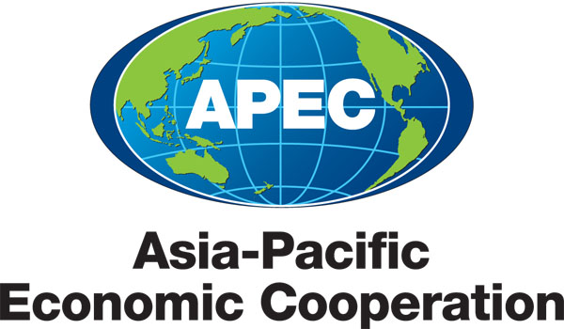
___________________________________________________________________________
2010/SOM3/SCE/001
Agenda Item: 2

Draft Annotated Agenda

Purpose: Consideration

Submitted by: SCE Chair

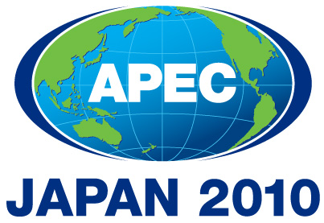 | Third SOM Steering Committee on Economic and Technical Cooperation Meeting  Sendai, Japan  24 September 2010

SOM Steering Committee on ECOTECH

24 September 2010

9h00 – 13h30

Sendai, Japan

Draft Annotated Agenda

1. Welcome by SCE Chair, Mr. Kurt Tong

2. Adoption of the Agenda

3. Reforming Economic and Technical Cooperation in APEC

3.1 Discussion of sub-fora accountability and communications:
- Discussion on the possibility of development of Guidelines for Lead Shepherd/Chair and Deputy Lead Shepherd/Chair to cover all fora under three APEC Committees.
- SCE Chair to present recommended ways to improve the effectiveness of SCE-COW;
- SCE Vice Chair to present a plan for implementation of recommendation 5 of the ECOTECH Framework, regarding sub-fora streamlining;
3.2 Enhancing APEC’s engagement with ABAC;
3.3 TATF to brief the meeting on core elements of project quality training;
3.4 APEC Secretariat to make presentation on the review of the prioritization trial and the quality criteria.
3.5 SCE to consider the medium term workplans of working groups/task forces.

4. SCE Fora Report

- SCE to consider the 2010 APEC Fora Report

- 2010 APEC Senior Official’s Report to APEC Ministerial Meeting on Economic and Technical Cooperation

- SCE to consider the first draft of the Report on ECOTECH

6. Independent Assessment of SCE Fora/Mandate of CTTF
6.1 Secretariat to present the progress report of the ongoing independent assessment of EPWG, MTF, MRCWG, FWG and SMEWG;
6.2 SCE to consider the recommendations of CTTF, HWG and TWG independent assessments;
  - CTTF Chair to present the request for the renewal of CTTF mandate.
6.4 SCE to review the process of independent assessments and discuss ways to improve its effectiveness and efficiency.

- Follow – up from the Aid-for-Trade Dialogue
- ADB representative to make a presentation of the report of the Regional Technical Group;
- Discussion on WTO Third Global Review proposal.

- Other issues:
  - ATCWG Terms of Reference – SCE to consider the revised ToR,
  - Japan to explain the US - Japan Coordination on emergency preparedness;
  - PSU to make a presentation on APEC’s new statistics portal - StatsAPEC;
  - 2010 Sectoral Ministerial meetings – Japan, China, Peru to brief the meeting on the outcomes/preparation of sectoral ministerial meetings to be held in 2010;
  - Document access - Members will be invited to decide on the classification of all documents relating to this meeting.

