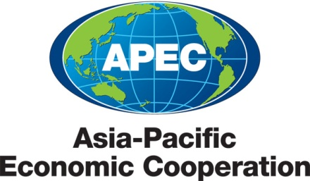
___________________________________________________________________________
2010/SOM3/SCE/002
Agenda Item:3.1

Improving the SCE-COW

Purpose: Consideration

Submitted by: SCE Chair

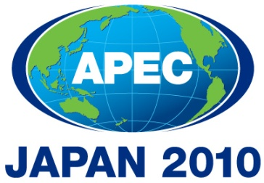 | Third SOM Steering Committee on Economic and Technical Cooperation Meeting  Sendai, Japan  24 September 2010

IMPROVING THE SCE-COW

The SCE-COW has met annually at SOM I since 2006 with the aim of bringing together SOMs and the chairs and lead shepherds of sub-fora reporting to the SCE. However, attendance and interest have lagged, giving rise to questions of how to improve SCE-COW's functioning, effectiveness, and usefulness to both SOMs and sub-fora leads.

The Issue: Two major factors explain lagging interest. Participants haven't always found value in SCE-COW discussions, either in terms of intrinsic interest or relevance to their work. Also, not all sub-fora meet on the margins of SOM, and the extra expense of coming only for the SCE-COW or for staying additional days to attend the meeting may be a burden for some economies.

Some elements of the SCE-COW agenda have proven valuable for attendees -- examples include discussions at the 2010 SCE-COW on communications and accountability issues -- and ensuring a vibrant SCE-COW should boost interest and attendance.

Possible Approaches: Possibilities do exist for making the SCE-COW agenda inherently more interesting. SCE-COW could continue discussions on procedural matters (looking at ways to strengthen guidance on policies and procedures for chairs and lead shepherds, for example) with a view to improving the actual operations of sub-fora.

SCE-COW could also schedule dialogues (akin to CTI's extremely useful trade policy dialogues) on current issues that are relevant to work of a range of sub-fora. Possible topics might include climate change and energy issues, engagement with multilateral organizations, successful policies to support SMEs, etc. Such discussions would serve the core SCE-COW objective of promoting cross-fora dialogue and understanding, and could benefit from participation by outside experts from academia or multilateral organizations. However, including on the SCE-COW agenda dialogues on such topics does run the risk of creating a parallel (to the SOM itself) forum for policy discussions, an outcome which may not be desirable.

Regardless, making meetings more interactive is imperative, and constructing the meeting agenda with the assistance of chairs and lead shepherds, as well as Secretariat program directors could assist in this area. Chairs and shepherds need to be know well in advance what to expect in order to best prepare to contribute to the discussion.

Ensuring that chairs and lead shepherds can attend SCE-COW meetings will be as great a challenge as making the agenda more attractive. Essentially this is a matter of funding. SOMs might consider establishing the expectation that economies assuming the chairmanship of SCE-related fora will provide sufficient resources to enable the chair to participate in SCE-COW meetings as well as regular meetings of the fora. One downside of this approach, of course, is that it might dissuade economies from volunteering to lead fora.

Alternatively, the Secretariat could set aside a budget to fund travel to the SCE-COW. Variations are possible. No funding would be provided for chairs of groups that meet on the margins of SOM. Funding would be restricted to chairs from travel-eligible economies, and to the chair or deputy chair (rather than other "representatives") to maximize constructive participation. The financial implications would have to be studied.

