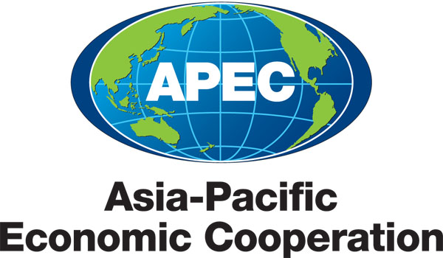
___________________________________________________________________________
2010/SOM3/SCE/004
Agenda Item: 3.3

Project Management Report to SCE

Purpose: Consideration

Submitted by: APEC Secretariat

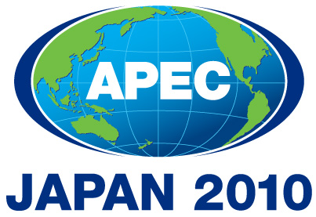 | Third SOM Steering Committee on Economic and Technical Cooperation Meeting  Sendai, Japan  24 September 2010

Project Management Report

The purpose of this paper is to respond to a request made by SCE members regarding total financial flows to APEC projects, and to provide feedback on the project prioritization trial undertaken during approval session 2 this year.

Total financial flows for APEC projects

- At its last meeting, SCE requested information about how much funding, in total, went towards APEC projects. This reflected a sense that the funds available via APEC project sessions represented only a portion of the total funds invested by members in APEC activities and initiatives.

- To provide SCE with at least an indication of the how much members directly provide to APEC projects, the PMU has prepared the table below. This shows, at a minimum, the amount of funding that economies provide independently to APEC projects in 2009 and to date in 2010.

Economy | Self -funding 2009 | Self funding 2010 (YTD)
Australia | $ 1,769,887.00 | $ 360,624.00
Brunei Darussalam | $ - | $ -
Canada | $ 255,061.00 | $ 46,291.00
Chile | $ 15,100.00 | $ 10,000.00
China | $ 1,640,220.00 | $ 827,783.00
Hong Kong, China | $ - | $ 32,182.00
Indonesia | $ 118,163.00 | $ 25,710.00
Japan | $ 2,587,605.00 | $ 680,098.00
Korea | $ 2,542,173.00 | $ 214,448.00
Malaysia | $ 28,180.00 | $ 26,960.00
Mexico | $ - | $ 10,000.00
New Zealand | $ 180,803.00 | $ 68,191.00
Papua New Guinea | $ - | $ -
Peru | $ 414,355.00 | $ 93,330.00
Philippines | $ 283,310.00 | $ -
Russia | $ 180,540.00 | $ 121,816.00
Singapore | $ 769,435.00 | $ 405,310.00
Chinese Taipei | $ 869,209.00 | $ 213,655.00
Thailand | $ 97,280.00 | $ -
United States | $ 5,090,214.00 | $ 1,643,035.00
Viet Nam | $ 269,726.00 | $ 44,601.00
TOTAL | $ 17,111,261.00 | $ 4,824,034.00

- The figures in the table are unlikely to provide a full and complete picture of each economy’s contributions. To provide a starting point for members to discuss levels of direct funding, the Secretariat has drawn only on figures that have been provided to APEC through two sources. Firstly, the amount of self-funding provided to a project as indicated on proposals / concept note; and secondly the indicated value of fully self-funded projects that have been loaded into the Project Database.

- The Secretariat has limited itself to this data because it is the only consistent information available. However, we do know that it means that significant levels of funding are not being captured, including:
  - Fully self-funded projects not loaded into the PDB;
  - Fully self-funded projects that have not specified a value when uploaded to the PDB; and
  - Other sources of funds such as contributions to the Policy Support Unit to undertake research, quantitative analysis or database projects.

- In addition, it is important to note that the Secretariat is not in a position to verify the accuracy of the self-funded amounts. ‘Self-funding’ can be applied to a variety of costs, including staff time, venue hire, field trips etc. that can be difficult to accurately quantify. Also, Different economies account for self-funding amounts independently, so the measurement of value may not be consistent across all members.

- These concerns aside however, the figures indicate that members contribute as much, if not more to APEC directly, than they do through contributions to OA, TILF and ASF. For example, in 2009, a total of $9,190,032 was available for disbursement through APEC project rounds. This amount is only just over half of the $17million that was directly funded by members. It is therefore likely that that there is a larger spread of “APEC” branded projects taking place across the region than is being centrally recorded, captured, or valued.

- If members are interested in getting a more accurate picture of the total financial flows to APEC projects, then a more thorough and active assessment is required. More accurate figures could be gathered if members provided more accurate information on all fully-self-funded projects; or if members volunteered the amounts they spend on APEC projects in a particular year. The Secretariat is able to assist in collecting further information if SCE members so desire.

Project prioritization trial and feedback

- As members are aware, APEC ran a trial of new procedures to select proposals for funding over session 2. This new approach:
- separated the assessments of priority and quality;
- introduced concept notes as a way for members to assess the relevance of each project;
- sorted all concept notes into ranks according to the 2010 APEC wide funding criteria
- prioritized the concept notes within each rank;
- provided in-principle approval to those concept notes of high enough priority to fit within the funding available; and
- retained the role of the Secretariat in assessing the quality of full proposals, while also providing a better opportunity for the Secretariat to assist proponents in their work.

- The Project Management Unit has assisted the BMC in reviewing the trial and assessing if the new approach to selecting projects should continue. Overall, the PMU recommends that the separation of priority and quality assessments be maintained. This would improve the probability that the most important project ideas are selected for funding, while also offering a chance for the Secretariat to assist proponents achieve satisfactory quality.

- As part of the trial review, the Secretariat also made suggestions on ways the process could be improved in the future. Views were gathered through discussions, as well as a survey of stakeholders (summary at Attachment A). One element of the new system that was highlighted for additional consideration is the application of the APEC wide Funding Criteria. Feedback from stakeholders is that more guidance is needed about how to interpret and apply the criteria to determine a project’s “rank”.

- This feedback reinforces the Secretariat’s experience in trying to calculate rankings for some concept notes. It was easy to identify a majority ranking preference for most notes. However, some were more challenging with the range of scores for some covering the whole spectrum, from Rank 1 (essential for regional economic integration (REI)) to Rank 4 (lower priority reform).

- While it may be preferable to have some objective approach to assess the rank of each concept note, the Secretariat is concerned about the practicality of implementing of such a requirement at this point in time. Firstly, APEC does not have an agreed method, nor the resources or time, to objectively and consistently measure and compare every project. Secondly, it may well be unreasonable to invest this time given APEC’s relatively small project budget. Finally, it seems likely that each member will have a different view about what is essential and what is only supportive to REI for their economy.

- As a result, the Secretariat believes that without further guidance from members, particularly SCE, that ranking assessments should be left to each member economy to decide. SCE may wish to consider how the Funding Criteria should be used when reviewing the 2010 criteria for 2011.

- A full copy of the trail review paper presented to BMC paper is available on the AIMP (2010/SOM3/BMC3/006). BMC will discuss the trail and make a decision about whether or not to maintain the selection system at its meeting on 22 September.

Recommendation

- SCE note the paper and provide direction to the Secretariat if any follow up actions are required.

APEC Secretariat
September 2010

Summary of Findings of the Prioritisation Survey

The Project Management Unit undertook a survey of key stakeholders to gauge satisfaction and elicit feedback on the recent project prioritisation and approval trial. BMC members agreed to the trial in April at BMC 2 (1020/BMC2/009rev.1). The purpose of the survey was to assess a variety of aspects of the first cycle of the trial, from a cross-section of primary stakeholders. This paper summarizes the findings of the survey and builds on other information-gathering steps, including consultations with key project stakeholders and an analysis of the distribution of the past five years of APEC projects.

Methodology

The PMU developed an online survey to seek views from respondents in all member economies. The PMU emailed a link to the online survey to potential respondents via program Directors and the BMC on August 6, 2010 and sent subsequent reminders to improve the response rate. Respondents included fora delegates, Project Proponents/Overseers, BMC members, Secretariat staff, Committee Delegates and other primary stakeholders

The survey began by identifying the respondent’s role in APEC (e.g. fora delegate, BMC delegate – respondents could mark all fields that applied to them). The remaining 23 questions focused on gaining respondents’ assessments of aspects of the prioritisation trial, including their thoughts on the timeliness of each stage, the ranking and prioritisation processes, the application of the APEC-wide Funding Criteria and the inclusion of the Concept Note as part of the process.

The final survey responses were collected Sept. 2, 2010. Results were then tabulated and viewed and analysed by members of the PMU. A summary of key findings and a link to the raw survey results were made available via email to the prioritization trial review group.

Results

Role in APEC

A total of 76 respondents completed the survey, representing a cross-section of APEC’s stakeholders. Of these, respondents described their roles as:

Fora delegate | Committee delegate | Project proponent / overseer | BMC delegate | APEC Secretariat | Principal decision maker | Other
33 (43%) | 19 (25%) | 18 (24%) | 12 (16%) | 12 (16%) | 9 (12%) | 5 (7%)

Timing of the ranking and prioritization of Concept Notes

In general, respondents are satisfied with the timing of the Concept Notes and project proposal processes:
- 74% answered that the process gave them the right amount of time to rank and prioritize Concept Notes, with 25% feeling that not enough time was provided.
- 67% felt that SOM2 and MRT did not interfere with the Concept Note process, while 33% felt they were too close.
- 86% felt that enough time was provided to prepare a full project proposal, with 13% wanting more time.
- Reactions were split on establishing a standardized deadline for submission of Concept Notes for fora endorsement, with 57% supporting the idea and 44% feeling a flexible deadline specific to each group is more sensible.

Comments included several respondents advocating that the stages be appropriately spaced between major meetings to enable economies time to properly complete their concept notes and full project proposals.

Ranking vs. prioritization

For the most part, respondents appear generally satisfied with the ranking and prioritization processes, but there remains some confusion over the difference between the two stages:
- 57% are clear about the difference between “ranking” and “prioritization”, but 44% feel that the difference is not always obvious.

Some respondents commented that rankings should relate only to the degree to which a project serves APEC's goal of regional economic integration, while others urged the Secretariat to adopt more specific and quantified criteria for prioritisation and ranking. Another respondent recommended changing the term “ranking” to “category” to avoid confusion over the language.

Ranking of Concept Notes

Respondents report that they find it useful for fora (working groups, sub-fora, task forces) to rank the Concept Notes:
- 85% agree that the ranking of Concept Notes by fora is useful, with 15% disagreeing.

This question generated the most number of comments, with most tending toward one of two viewpoints. The following serve as representative examples:
“Given that sub-fora, working groups and task forces are experts in their respective areas, committees should be bound by the ranking they arrived at.” –fora delegate
“Committees have a better appreciation of overall priorities for APEC and the different activities of each sub-fora contributing to those priorities. Ranking of sub-fora groups should strongly guide the committee on their respective ranking.” – fora delegate

As is evident from the above comments, there is some disagreement on whether the ranking of fora should be binding on Committees:
- 57% of respondents believe fora rankings should be binding, while 43% disagree.

A greater majority of respondents believe the ranking of Committees and SFOM should be of primary importance in project selection:
- 68% believe Committee/SFOM rankings should be binding on PDMs; 32% disagree.

CTI, SCE, EC, SFOM delegates and PDMs say they are using the ranking justifications to help them prioritize projects.
- 73% find the justifications useful in determining their own priorities.

Funding Criteria

The survey data indicates that there is confusion among some parties about how to apply the current APEC-wide Funding Criteria, endorsed by SOM at SOM 1 2010.
- 72% of respondents agree that using the Funding Criteria is straightforward, but 28% believe that it was difficult to use at times.

Respondents believe that there are some ways in which the Funding Criteria can be improved. Given options, respondents selected the suggestions in the following table (respondents were able to tick as many suggestions as they liked). Associated comments tended to reiterate the last option in the table; several respondents state that they would like clearer guidance about how to interpret and apply the Funding Criteria. Many respondents believe that clearer guidance would not only assist users of the criteria to appropriately guide their decisions, but would also help PP’s and fora members understand why some projects were given in-principle approval and others were not.

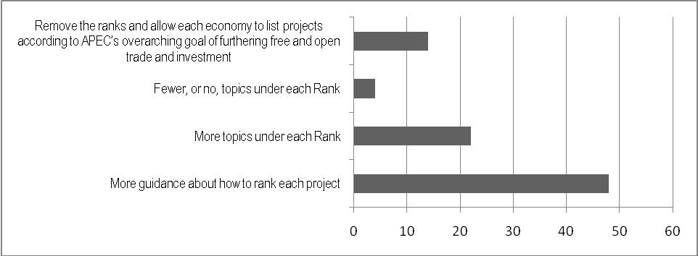
# of responses:

Templates

Most stakeholders seem satisfied with the templates, but still have suggestions for improvement.
- 81% agree that the ranking and prioritization templates are easy to follow, while 19% answered that they did not always know what was expected.
- 94% feel that the Concept Note templates are easy to complete and 86% agree that the Concept Notes are easy to assess for priority.
- 78% agree that the project proposal forms are easy to complete, but 22% do not feel as such.

Many suggestions were put forward to improve the ranking and prioritization templates. Given options, respondents selected the following suggestions (respondents were able to tick as many suggestions as they liked):

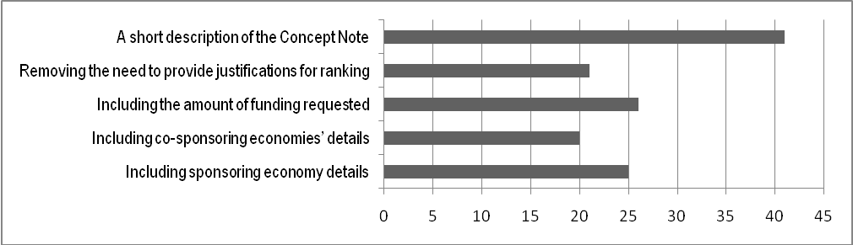
# of responses:

Comments on improving the Concept Note template ranged from including gender and sustainability, to increasing the maximum length allowed, and requiring a detailed budget with the Concept Note. Respondents’ suggestions to improve the project proposal template included requests to avoid duplication in questions, impose a stricter length limit and to provide a more user friendly guidebook.

Support from PMU

In general, the survey indicates that the Secretariat is providing adequate support throughout the proposal process, but some improvement is needed.
- 82% feel there was sufficient support provided throughout the Concept Note, proposal preparation and ranking/prioritization processes. 18% felt the support was insufficient.

Suggestions for improvement from the Secretariat side include recommendations to:
- Implement standardized datelines throughout the process
- Design a more systematic mechanism for circulating comments on draft proposal submissions
- Better ensure Chairs, PDs and committee members understand the project management systems

Analysis

Overall, the feedback is encouraging, with the majority of respondents positive about the trial and the new approach to project selection. On a more detailed level, some of the key results are:

Respondents want more guidance on how to use the Funding Criteria
A significant number of respondents (61%) want greater guidance about how to interpret the Funding Criteria to determine the Rank of proposals. Confusion about how to measure “the degree to which a project contributes to APEC’s overarching role of furthering free and open trade” might explain the variation in Rankings for some proposals submitted in Session 2. Some proposals were ranked everything from 1 – 4, creating some difficulty in determining an appropriate rank. This issue will need to be addressed by Committees to facilitate more effective management in the future.

Confusion remains over ranking and prioritisation
Besides confusion about how to determine the appropriate “rank” for concept notes, the comments received indicate that members have a mixed understanding of how the ranking and prioritisation processes work, and the link it has to in-principle funding approval. This issue will need to be addressed through improved communication and explanation about the process, when it is ultimately settled. The Secretariat has a role to play in this, as do Committee delegates to their domestic stakeholders.

Interestingly, the largest number of comments were in response to whether it is useful for sub-fora / working groups / task forces to rank their concept notes. The majority of respondents (85%) think that it is useful for these groups to rank their proposals, but only 57% think this ranking should be binding on Committees. This might indicate that while respondents think that sectoral expertise is important, they do concede that Committees might have other views or that it might cause logistical concerns. The comments show a very high level of frustration with the sub-fora rankings being ignored or overturned. Again, this might prompt Committees to consider the best way to communicate how sub-fora rankings are used through the prioritisation process.

Respondents are comfortable with the timing and basic steps in the prioritisation trial, but want more certainty and clarity about the timeframe
Respondents were generally comfortable with the amount of time given for each step, but comments indicate that some stakeholders felt that timelines were not made clear, and announced too late. The PDs assisting the CTI and SCE Chairs strongly indicated that those Committees needed more time to undertake the ranking process. This should be able to be accommodated in future timelines.

Templates can be improved
A number of suggestions were made to improve the concept note, ranking and prioritisation and project proposal templates. Most of these can be easily incorporated into the templates. However, the PMU is not comfortable with the suggestion from 54% of respondents to include a short description of the concept note into the ranking template. Including a summary of each concept note raises the question of ‘who summarises?’ (it could be controversial for the Secretariat to do so). It also raises the concern that members only review the summary, not the whole note. It is questionable if the information in the concept note alone is enough to accurately assess its rank.

Communication about APEC project processes need to be improved
From a range of comments in the survey, a clear message is that the Secretariat needs to improve the communication of project decisions and processes to APEC groups. The results indicate that while project stakeholders are not asking for a return to the old method of project selection, they are asking for more detailed information on how the new process works, the relevant timeframes, and how to best use project tools and templates.

This, quite reasonable, demand will need to be continually addressed, particularly for groups that meet outside of the regular SOM meetings. The new Guidebook on APEC Projects offers the Secretariat a good opportunity to explain project processes to groups.

A total of 76 concept notes were submitted for consideration in session 2. 42 received in-principle approval. SCE and associated working groups submitted a total of 48 concept notes for consideration, with 25 granted in-principle approval.

