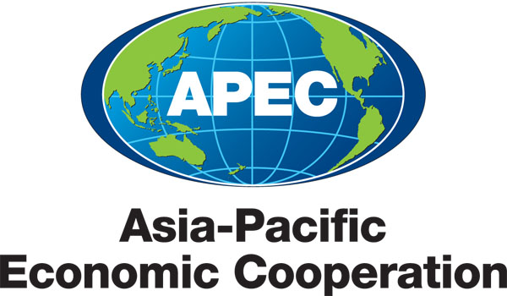
___________________________________________________________________________
2010/SOM3/SCE/008
Agenda Item: 3.5

TEL Medium Term Plan

Purpose: Consideration

Submitted by: TEL Lead Shepherd

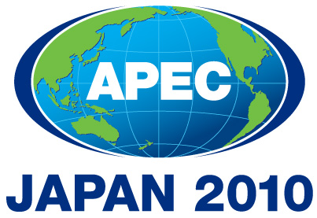 | Third SOM Steering Committee on Economic and Technical Cooperation Meeting  Sendai, Japan  24 September 2010

MEDIUM TERM WORKPLAN
(2010 – 2015)
Name of the Group: TELECOMMUNICATIONS AND INFORMATION WORKING GROUP

- MEDIUM-TERM GOALS (please provide some explanation/description of the medium term goals that the group will work toward in order to facilitate achievement of APEC-wide strategic objectives )

TEL has drafted a Strategic Action Plan that would guide its work for the period 2010-2015, cognizant of the overarching APEC objectives as well as current APEC priorities. TEL’s medium term workplan will focus on the following elements: develop ICT to promote new growth; enhance socio-economic activities through the use of ICT; promote a safe and trusted ICT environment; promote regional economic integration; and strengthen cooperation in the ICT sector. The draft strategic plan will be submitted for endorsement of TEL Ministers in October 2010.

- WORK PROGRAM

goals/objectives (please indicate the ecotech priority workstream that they support) |  | Action items/Specific processes/activities |  | Expected Outcomes |  | Timeframe |  | Cooperating party (mo/other apec fora)
1. Develop ICT to Promote New Growth  (supports inclusive growth) |  | Expand networks to achieve universal access to broadband in all APEC economies by 2015  - Progress reports at DSG meetings on status of UAB implementation by each economy |  | Universal access to broadband in APEC member economies |  | 2015
 |  | Identify and disseminate strategies to assist developing economies to deploy broadband networks.  - Workshop and Report on Best Practices in Infrastructure Sharing to Facilitate Universal Access to Broadband  - Workshop on Broadband usages to enhance networks and services (TEL-03/2009A)  - Survey on demand-based policy approaches to foster universal broadband access (TEL-04/2009S) |  | Implementation by members of best practices on infrastructure sharing to facilitate universal access to broadband |  | 2011-2015
 |  | Encourage economies to develop and implement strategies to make ICT more accessible to people with disabilities. |  | Provide information access by all means to people with disabilities in APEC economies |  | 2011-2015
 |  | Promote public and private sector adoption of IPv6 infrastructure through information sharing and technological collaboration.  - Workshops on IPv6 |  | Greater understanding among members on the depletion of IPv4 addresses and the need to transition to IPv6 |  | 2010 |  | APNIC  ISOC
 |  | Develop and promote guidelines to assist economies to effectively transition to IPv6.  - Adoption of IPv6 Guidelines and Action Plan |  | Greater number of economies transitioning to IPv6 |  | 2011-2015 |  | APNIC  ISOC
 |  | Provide a platform for information exchange and the development of best practice approaches for efficient infrastructure sharing within economies  - Workshop and Report on Best Practices in Infrastructure Sharing to Facilitate Universal Access to Broadband |  | Implementation by members of best practices on Infrastructure Sharing to Facilitate Universal Access to Broadband |  | 2011
2. Enhance Socio-Economic Activities through the use of ICT(supports inclusive and sustainable growth) |  | Share information and promote cooperation among economies to facilitate the introduction of advanced and emerging technologies and services.  - Smart grids and APII testbed projects |  | Having an information- sharing system and a technology-transfer program and the latest expertise in New Generation Internet technology for APEC TEL members to improve the interconnectivity and interoperability of intra-regional research networks to enhance regional and global connectivity |  | 2011-2015
 |  | Develop and promote ICT applications such as smart grids and sensor networks to seek outcomes including:  - enhancing economic efficiency and growth; and  - environmental benefits. |  | Provide a platform for economies to share and have exchanges on the latest technology developments and the benefits it can bring domestically and to the APEC region |  | 2011-2015
 |  | Enhance the need for human resource development and personnel exchanges that provide the foundation for balanced and sustainable growth in ICT |  | Sharing human expertise and best practice in ICT among member economies for sustainable growth |  | 2011-2015
 |  | Share best practices for ICT applications, such as  - developing and promoting best practices for public and private sectors to implement Green ICT;  - enhancing the effectiveness of disaster response by strengthening disaster management networks;  - developing and promoting best practices for using ICT to more efficiently deliver services online including e-Commerce, e-Health, e-Education, and e-Government; and  - implementing demonstration projects |  | Implementation by economies of the Best Practices on Green ICT  Improved Disaster Management in the region  Establishment of a model platform for NGO-government partnership in times of disaster |  | 2011-2015
Promote a Safe and Trusted ICT Environment (supports human security) |  | Promote the development and dissemination of strategies for fostering a protected ICT environment, with a focus on consumer protection, through securing personal information and promoting network security technologies  - PKI and e-authentication training programs  - DNSSEC best practices guidelines and technical training  - Guidelines on mobile device security  - Guidelines on the Provision of Consumer Information on International Mobile Roaming |  | Establishment of an ICT environment that protects consumers and businesses |  | 2011-2015
 |  | Promote the development of effective cyber security initiatives, in accordance with the APEC Cybersecurity Strategy and the APEC Strategy to Ensure Trusted, Secure and Sustainable Online Environment, including through distribution of best practice approaches, information sharing, technical cooperation, training and education.  - Workshops and Training on Cybersecurity Policy Development |  |  |  | 2011-2015
 |  | Promote and build capacity to implement effective cyber security awareness raising initiatives, and integrate these into broader APEC activities where possible.
Collaborate with industry, particularly ISPs, to develop options for effective cyber security initiatives against cyber threats.
- Cyber Security Voluntary Internet Service Provider Codes of Practice

Share information and develop strategies for the protection of vulnerable groups online, particularly children. For example, implement capacity building initiatives to assist economies’ law enforcement agencies protect children online.
- APEC Training program for Preventive Education on ICT Misuse

 |  | Foster a secure, safe and productive Internet economy by promoting information exchange, intellectual property protection and privacy rights.
Promote Regional Economic Integration  (supports REI and structural reform) |  | Develop ICT policy and regulatory frameworks that facilitate free and open trade arrangements within the APEC region.  - Reference Guide for Telecommunication Elements of RTAs and FTAs |  | Implementation of the WTO Telecoms Reference Paper by most economies |  | 2015
 |  | Increase Economies’ participation in the Mutual Recognition Arrangement (MRA) for conformity assessment and implement the MRA for equivalence of technical requirements.  - Market Surveillance to collect information on the current market surveillance practices among APEC member economies and Survey on implementation of MRA-CA to determine which economies are implementing the MRA and to identify reasons/ difficulties faced by economies which are not yet fully implementing the MRA |  | More participation from and full implementation by APEC economies of MRAs |  | 2015  2010
 |  | Build capacity by training APEC policy makers and regulators to promote competition and transparency in the interconnection and international mobile roaming markets. |  | Greater number of policy makers and regulators trained to implement measures/lessons learned to promote transparency and competition in their respective
 |  | Encourage deployment of infrastructure and mechanisms to reduce connectivity costs, including through increasing industry competition by promoting free and open trade and investment |  | Introduction and implementation of infrastructure and mechanisms to increase industry competition
Improve consumer awareness of communications complaint handling mechanisms, service prices and substitute technologies through the publication of reports and other awareness raising activities.
- Guidelines on the Provision of Consumer Information on International Mobile Roaming

 |  | Encourage Economies to actively participate in TEL projects and exchange knowledge and experience to facilitate streamlined regulatory measures that encourage competition and investment in the market  - Annual industry and regulatory roundtable  - Stocktake of Regulatory Convergence in the APEC Region |  | Policy and regulatory measures that encourage competition implemented by economies |  | - 2010-2015  - 2010
Strengthen Cooperation in the ICT Sector (supports REI, sustainable and inclusive growth) |  | Enhance coordination of ICT related activities within APEC, including with:  - The CTI to strengthen regional economic integration and promote free and open trade and investment, and identify how ICT can enhance trade logistics.  - the Electronic Commerce Steering Group and the Counter Terrorism Taskforce to promote a trusted ICT environment;  - the Health Working Group to identify effective e-Health applications; and  - the Emergency Preparedness Working Group to promote the benefits of using ICT for emergency preparedness and disaster prevention/mitigation |  | Greater collaboration with other APEC fora on cross-cutting issues |  | 2010-2015 |  | ECSG  CTTF  HWG  EPWG
 |  | Enhance outcomes and minimise duplication of effort by collaborating with relevant multilateral organisations including OECD, APT, and ITU, and internet-related technical and administrative bodies on issues such as:  - developing, implementing and promoting relevant cyber security initiatives;  - reducing international communication costs; and  - addressing relevant environmental challenges. |  | Greater collaboration with other multilateral organizations on cybersecurity, international communication costs and using ICT to address environmental challenges |  | 2010-2015 |  | OECD  APT  ITU

