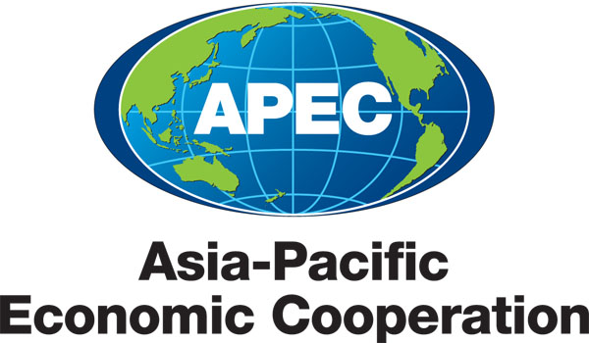
___________________________________________________________________________
2010/SOM3/SCE/011
Agenda Item: 3.5

MTF Medium Term Workplan

Purpose: Consideration

Submitted by: MTF Chair

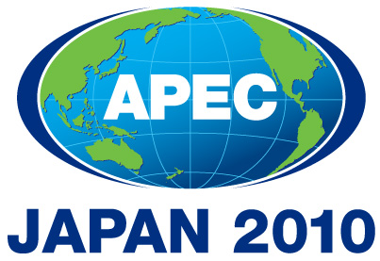 | Third SOM Steering Committee on Economic and Technical Cooperation Meeting  Sendai, Japan  24 September 2010

THE MEDIUM TERM WORKPLAN
(2010 – 2015)
Name of the Group: Mining Task Force

- MEDIUM-TERM GOALS (please provide some explanation/description of the medium term goals that the group will work toward in order to facilitate achievement of APEC-wide strategic objectives )

The main goals of the MTF activities are ECOTECH priorities as well as 10 APEC mining policy principles.

II. WORK PROGRAM

goals/objectives (please indicate the ecotech priority workstream that they support) |  | Action items / Specific processes / activities |  | Expected Outcomes |  | Timeframe |  | Cooperating party (mo/other apec fora)
- mining and metallurgy regulatory improvement |  | information and experience sharing between member economies on regulatory mining and metallurgy issues |  | transparency of the regulatory principles and practices in mining and metallurgy for APEC economies
 |  | structural reforms in mining and metallurgy |  | APEC best practices & lessons learnt in structural reforms conducted in mining and metallurgy
 |  | regulation of integrate mining life cycle |  | promotion of integrating approaches in mining regulation
 |  | evidence based, transparent and objective-based measures of regulation |  | APEC best practices & lessons learnt in up-to-date regulation methods implementation in mining and metallurgy
- market transparency, facilitation of trade and investment |  | investment certainty fostering / formulation of clear and predictable investment policies |  | predictability of mining and metallurgy investment regimes in APEC economies |  |  |  | CTI, MAG, IEG
 |  | APEC mining and metallurgy in global market |  | survey and/or forecast of APEC mining and metallurgy role in global market, trends and challenges
 |  | analysis of export restrictions in mining and metallurgy |  | reduction of export restrictions in APEC economies to the level of the WTO rules
 |  | open minerals and metals markets |  | promotion of open minerals and metals markets in APEC
 |  | attracting investment in mining and metallurgy |  | balanced growth of the APEC economies through the growth of investment in mining and metallurgy
- knowledge-based mining and metallurgy |  | information sharing and cooperation on up-to-date technologies issues |  | mutual comprehension of the mining and metallurgy science and technology issues among MTF members |  |  |  | IST
 |  | surveys of the APEC economies’ best mining and metallurgy technologies |  | APEC database of new technologies in mining and metallurgy
 |  | facilitation of research and technology flows |  | new level of science and technological cooperation among APEC economies
 |  | new minerals exploration, extraction, and pollution control technologies |  | possibility to transit to the clean mining and metallurgy
- sustainable development in mining and metallurgy |  | producing, consuming, recycling or disposing of materials and products made from minerals and metals in responsible manners |  | sound growth through providing the safeguarding the life quality |  |  |  | SD Initiative
 |  | human resources in mining and metallurgy |  | developing of the human resources in mining industry and metallurgy, indigenes, local communities
 |  | SME in mining and metallurgy |  | expansion of small and medium enterprises role in mining
 |  | responsibility sharing in mining life cycle |  | encouraging all participants in the life cycle of a material or product to take direct responsibility for their area of action
- promotion and supporting of the relevant initiatives of the mining industry, metallurgy and stakeholders |  |  |  | MTF is a platform for APEC economies to strengthen policy dialogue and capacity building in mining and metallurgy

Developing stable and efficient markets through structural reform
Developing stable and efficient markets through structural reform
Promoting the development of knowledge-based economies Facilitating technology flows and harnessing technologies for the future
Addressing social dimension of globalization Developing stable and efficient markets through structural reform
Safeguarding the quality of life through environmentally sound growth

