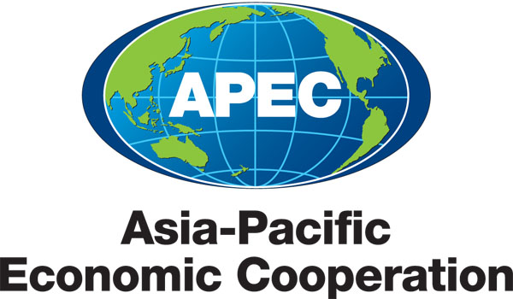
___________________________________________________________________________
2010/SOM3/SCE/012
Agenda Item: 3.5

EPWG Workplan

Purpose: Consideration

Submitted by: EPWG

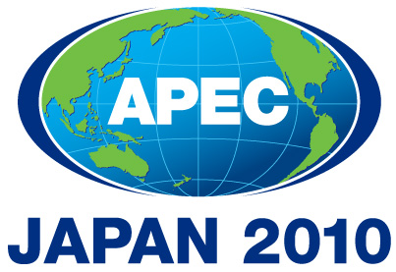 | Third SOM Steering Committee on Economic and Technical Cooperation Meeting  Sendai, Japan  24 September 2010

Proposed Workplan for 2011
APEC Emergency Preparedness Working Group

- Proposed Work Plan for 2011 in Response to Leaders/Ministers/SOM/SCE Priorities and Decisions, and to ABAC recommendations.

The APEC Emergency Preparedness Working Group (EPWG) was elevated from a non-permanent task force – the Task Force for Emergency Preparedness or TFEP – to a permanent working group in 2010. The Group has a broad mandate to build the capacity of APEC economies to mitigate, prepare for, respond to and recover from emergencies and disasters; and to improve coordination and cooperation on emergency and disaster preparedness efforts within APEC.

The EPWG – along with the health and counter-terrorism working groups – is an important part of APEC’s human security agenda to protect business, trade and economic growth from disruptions.

High-Level Guidance for 2011

Responding to the instructions of APEC Senior Officials issued in 2009, the Group has a particular focus on strengthening business resilience and the participation of the business sector.

In 2009, Senior Officials also reiterated that APEC’s efforts should complement, not duplicate, other international efforts and should be sustainable – cognizant of the areas in which APEC can add value, the complex field of organisations involved in disaster preparedness, management, coordination and relief work, and APEC’s resource limitations.

In November 2009, APEC Ministers observed that ‘recent catastrophes in the region - such as the devastating typhoons that hit China, Japan, the Philippines, Chinese Taipei and Viet Nam, and the earthquakes in Indonesia - remind us of the importance of APEC's work in disaster management, relief and recovery.’ Ministers welcomed the renewed mandate and the work of the Taskforce on Emergency Preparedness (TFEP) in 2009 on strengthening business and community resilience, enhancing public-private partnerships, and reducing disaster risks. APEC Leaders also welcomed APEC’s emergency preparedness work.

In June 2010, APEC Ministers’ Responsible for Trade instructed senior officials to intensify efforts to reduce and prepare for potential threats and disruptions to commerce and trade, and to strengthen the region’s capacity to achieve a secure and resilient economic and social environment. They stated that “we must build our future through concerted efforts in this area.”

APEC 2011 Host, the United States, has signalled that public –private partnerships and the engagement of the business sector in emergency management and preparedness will be a focus of its Human Security – emergency preparedness – agenda.

Medium-Term Objectives

The APEC Strategy for Disaster Risk Reduction and Emergency Preparedness and Response in the Asia Pacific Region, which was endorsed by the TFEP in November 2008 as a ‘first edition’ and welcomed by Leaders and Ministers, identified that the core objectives of APEC economies and the TFEP, now EPWG, during the period 2009 to 2015 should be that:
- political decision-makers in APEC economies better understand the economic and social costs of disasters and, equally, the human and economic costs of failing to take action;
- gaps in regional disaster risk reduction approaches are identified and shared to support the delivery of targeted capacity-building initiatives; and
- a suite of practical mechanisms is developed that will aid APEC economies to build business and community resilience.

In line with its present mandate and the internationally-endorsed United Nations Hyogo Framework for Action (2005-2015), the Working Group also seeks to help achieve the following in APEC economies by 2015:
- reduced risk of disasters, including through increased risk awareness and assessment, improved knowledge development systems, strengthened public commitment and institutional frameworks, implementation of disaster risk reduction measures; and the establishment of effective early warning systems;
- increased business and community resilience, including an increased ability to absorb the shocks of hazard impact, improved capacity to bounce back during and after a disaster, and increased opportunities for change and adaptation following a disaster; and
- better coordination and cooperation in terms of emergency and disaster preparedness and response efforts, including with other international organisations.

In achieving these objectives, the Working Group acknowledges that: risk should be managed prospectively; disasters should be prepared for jointly and mitigated, where possible; and recovery from disasters should be achieved using a long-term development approach.

The Working Group will seek to marshal its modest resources to help member economies to achieve these mid-term objectives by 2015.

Priorities in 2011

In accordance with the annual directives of APEC Leaders and Ministers and the APEC 2009-2015 Strategy for Disaster Risk Reduction and Emergency Preparedness and Response, the Working Group’s priorities are:
- business and community resilience
- public-private partnerships
- disaster risk reduction
- cooperation and coordination with regional and international stakeholders
- preparations for the recovery phase

Planned activities in 2011

The following activities are planned in 2011:
- International Disaster Management Course (Singapore, March 2011) (subject to funding)
- Fifth APEC Senior Disaster Management Officials Forum (United States, 2011) that will focus on public-private partnerships, business resilience, corporate social responsibility (CSR) and business continuity
- Workshop on School Earthquake Safety in APEC Economies: Reducing Risk and Improving Preparedness (United States, 2011)
The EPWG will also:
- Continue to explore opportunities to undertake projects and activities that will foster collaboration with the private sector; encourage the participation of the business sector in emergency management, including mitigation and preparedness efforts; and build the resilience of the business sector to disasters. Projects might include: business continuity planning, business resilience standards, and tools to help businesses assess their readiness for disasters.
- Consider the development of a regional Emergency Management Handbook.
- Continue to explore with the APEC Climate Centre the formulation of a multi-year, multi-fora project to develop an extreme climate prediction system with specific applications for emergency management planning;
- Continue to investigate the possibility of a workshop for 2011 on attracting, recruiting and retaining emergency management volunteers;
- Support the implementation by APEC members of the 2009-15 Strategy, including through the development of an implementation plan;
- Improve the Group’s outreach and communications efforts including by improving the effectiveness and content of the Group’s website; issuing an electronic newsletter; and possibly creating a virtual network with prominent disaster management and emergency preparedness institutes;
- Collaborate further with other APEC fora, including possibly on logistics/supply chain recovery following a large-scale disaster, the economic benefits of risk reduction for SMEs, climate change and disasters, gender integration in disaster management, and the structural and non-structural measures associated with disaster risk reduction; and
- Consider addressing food security concerns in its activities on disaster preparedness, risk reduction and recovery.

Working Group Meeting

The Working Group is scheduled to meet in 2011 in the margins of SOM1 in Washington DC. As per the Group’s terms of reference, face-to-face meetings will be held once a year and on an as needed basis. Additional meetings in 2011 will be scheduled only if needed.

Steering Committee

The EPWG will continue to utilise its virtual Steering Committee to assist the Working Group and its co-Chairs to advance the Group’s mandate and work plans, and to assess projects. Membership is voluntary.

- Anticipated Activities and/or Proposed Work Plan with outside organisations in response to Ministers’ call for greater engagement with:
A) Business Sector; and
- Other Organisations/Stakeholders, including the IFIs and other International Organisations

The EPWG recognises that greater collaboration with other international bodies helps to identify gaps and avoid the duplication of effort. The Working Group will continue to involve key players – including business sector representatives, the APEC Business Advisory Council, UN agencies, international and regional organisations, and non-governmental organisations – in its activities, particularly the Senior Disaster Management Officials Forum. If resources permit, Working Group representatives will also continue to accept invitations to major ministerial and other emergency preparedness events.

Also see the list of planned activities above.

- Identify cross cutting issues and explain how they will be coordinated across Fora.

The Working Group is mandated to coordinate all of APEC’s emergency and disaster preparedness and response efforts. The EPWG will continue to collaborate with a range of APEC fora, including the Gender Focal Point Network (women in times of disaster), APEC Climate Centre (climate prediction systems), Health Working Group (communicable diseases and pandemics), and Small and Medium Enterprise Working Group (SME Crisis Management Centre), as well as the APEC Business Advisory Council (private-public partnerships). As noted above, the Working Group will continue to explore further opportunities to work with other sub-fora.

- Expected Outcomes/Deliverables For 2011.

Expected EPWG deliverables for 2011 include:
- further practical mechanisms to assist APEC economies to build business and community preparedness, including through: the Workshop on School Earthquake Safety; and if approved/funded, the International Disaster Management Course; the Senior Disaster Management Officials Forum and other projects which assist development of business continuity planning, business resilience standards, and tools to help businesses assess their readiness for disasters.
- increased business and community resilience, including through: the Workshop on School Earthquake Safety; and if approved/endorsed the Senior Disaster Management Officials Forum; and the promotion of ppp’s; business continuity plans (BCPs) and CSR.
- better coordination and cooperation in terms of emergency and disaster preparedness and response efforts, including through the Senior Disaster Management Officials Forum; the proposed regional Emergency Management Handbook (if approved/endorsed); improved outreach and communication activities such as the website and virtual network; and cooperation with other APEC fora.

