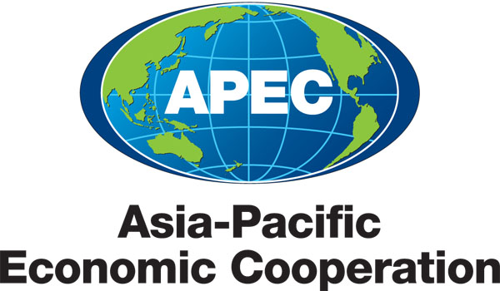
___________________________________________________________________________
2010/SOM3/SCE/013
Agenda Item: 3.5

SMEWG Medium Term Workplan

Purpose: Consideration

Submitted by: SMEWG Lead Shepherd

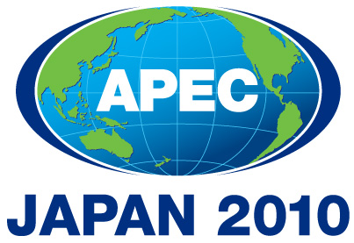 | Third SOM Steering Committee on Economic and Technical Cooperation Meeting  Sendai, Japan  24 September 2010

MEDIUM TERM WORKPLAN
(2010 – 2015)
Name of the Group: Small and Medium Enterprises (SMEWG)

- MEDIUM-TERM GOALS (please provide some explanation/description of the medium term goals that the group will work toward in order to facilitate achievement of APEC-wide strategic objectives )

Regarding APEC’s medium-term ECOTECH priorities, the Priority Work Streams are Regional Economic Integration, Addressing Social Dimension of Globalization (Inclusive Growth), Safeguarding the Quality of Life through Sustainable Growth, Structural Reform and Human Security.
SMEWG 2010 main theme Strategy for Reinvigorating Economic Growth with Dual Engine: SME and Asia-Pacific Economy including Improving business environment of SMEs and enhancing business support programs, and the SMEWG Strategic Plan 2009-2011 addressed those ECOTECH priorities.

- WORK PROGRAM

goals/objectives (please indicate the ecotech priority workstream that they support) |  | Action items/Specific processes/activities |  | Expected Outcomes |  | Timeframe |  | Cooperating party (mo/other apec fora)
- Regional Economic Integration (REI) and Addressing Social Dimension of Globalization (Inclusive Growth) |  | Help SMEs build up market access capabilities and make market information easily available to all |  | Ongoing implementation of the SMEWG Strategic Plan, including progress report in each priority Business Environment, Building Management Capability and Entrepreneurship Promotion; Market Access and Internationalisation; Innovation and Financing. by the Champion economies.  (PSU) presented the findings from their study of data availability to support the Medium-term KPIs and measurable outcomes of the market access and internationalisation priority area. |  | Ongoing (009-2012) periodical reports in Oct 2009 and June 2010  Completed June 2010
- Addressing Social Dimension of Globalization (Inclusive Growth) |  | Way forward for SMEs after the economical crisis. |  | SMEs Ministerial Meeting main theme is Strategy for reinvigorating economic growth with a dual engine: SMEs and the Asia Pacific Economy focusin on: The Impact of the Economic Crisis on SMEs, and Countermeasures Implemented in Response; Short-Term Prospects for SMEs, and SME Measures Required of APEC. Additionally, Prospects for APEC SME Policy: Looking toward 2020. |  | Ongoing, Ministers will meet in Japan on 2 and 3 Oct 2010.
- Regional Economic Integration |  | EoDB Seminars and Workshops:  - Employing Workers (Completed 2010)  - Trading Across border (Completed 2009)  - Access to credit (Completed 2009)  - Best Practice Guide - Improving Business Regulation in APEC Member Economies, based on knowledge Shared from the Ease of Doing Business/Private Sector Development Workshop Series (ongoing) |  | Facilitating the Leaders’ recommendation to improve in 25% five key areas of doing business by 2015. |  | Three completed and one ongoing |  | EC
- Regional Economic Integration |  | Also take into account the 2009 Ministerial Statement which mentioned to facilitate women’s access to capacity building programmes, technology and infrastructure; and supporting measures to promote employment for women in informal and vulnerable sectors, access to financing, growth in women-led SMEs and support for social enterprises for women: Support Women’s Entrepreneurship Summit to be held back to back SMEs Ministerial meeting. |  | Promote and improve governments’ awareness to support gender initiatives to assist Small and Medium Enterprises (SME) and Micro-Enterprise (ME) development. |  | Ongoing |  | SCE/GFPN
- Human Security |  | APEC Pandemic Preparedness for SMEs Train the Trainer Workshop (Completed 2010) |  | The aim of the workshop was to share SME experiences from the 2009 H1N1 influenza pandemic, key concepts of protecting workforce health, and Business Continuity Planning measures. |  | Completed June 2010 |  | HWG
- Addressing Social Dimension of Globalization (Inclusive Growth) |  | Increase SMEs visibility and APEC SMEWG contributions among members economies. |  | Assessment of Comm Strategy proposed at the 30th SMEWG meeting in Hong Kong China, June 2010 |  | To be discussed at the 30th SMEWG meeting in Gifu, Japan.
- Regional Economic Integration |  | Innovation Seminar for SMEs, Part of the Daegu Initiative (2006-2010) and one of the priorities of the current SMEWG Strategic Plan. |  | The seminar offered a platform for APEC economies to discuss SMEs innovation policies, regional case studies, and shared on opportunities to improve the ability of economies to implement and assess SMEs innovation policies. |  | Completed June 2010
- Regional Economic Integration |  | APEC SME Crisis Management Center |  | i) to familiarize workshop trainees with the nature of international crises and their impact on SMEs; ii) to raise awareness of the importance of a Crisis Management Plan (CMP) among members. |  | Completed June 2010
- Regional Economic Integration (REI) and Addressing Social Dimension of Globalization (Inclusive Growth) |  | APEC International Workshop and Training on SMEs Trading Houses |  | Shared experiences on the importance of trading houses in strengthening SMEs’ access to the global export network. |  | Completed Oct 2009.

