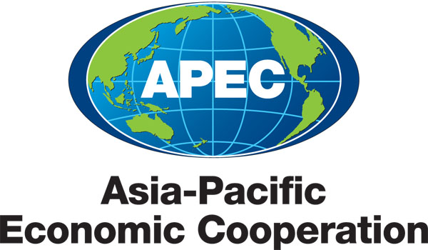
___________________________________________________________________________
2010/SOM3/SCE/016
Agenda Item:3.5

TWG Medium Term Workplan

Purpose: Consideration

Submitted by: TWG Lead Shepherd

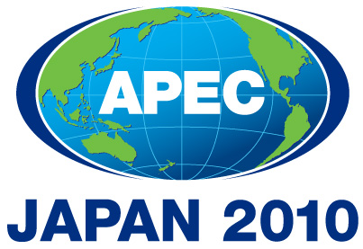 | Third SOM Steering Committee on Economic and Technical Cooperation Meeting  Sendai, Japan  24 September 2010

MEDIUM TERM WORKPLAN
(2010 – 2015)
Tourism Working Group

- MEDIUM-TERM GOALS
- Remove impediments to tourism business and investment
- Increase mobility of visitors and demand for tourism goods and services
- Sustainably manage tourism outcomes and impacts
- Increase mobility of visitors and demand for tourism goods and services

- WORK PROGRAM

goals/objectives |  | Action items/Specific processes/activities |  | Expected Outcomes |  | Timeframe |  | Cooperating party
- Remove impediments to tourism business and investment  ECOTECH:  Regional Economic Integration |  | - Assess the APEC environment for expanding tourism business opportunities and flows:  - Develop and model scenarios for tourism development that feed back into quantifiable measures such as local employment, taxation revenues and economic, social and environmental sustainability;  - Identify impediments for conducting business in-market by international travel and tourism firms entering the market  - Collaborate with multilateral tourism organizations to ensure private sector input (e.g. PATA and WTTC)  - Promote and facilitate productive investment in tourism and associated sectors;  - Engage IMF and World Bank in delineating criteria for supporting tourism development  - Collaborate with investment workshop opportunities to support SME travel and tourism.  - Investigate venture capital interests and criteria for supporting entrepreneurial enterprises for travel and tourism, including technology driven enterprises  - Ease the point of entry process for travellers in the APEC region  - Engage in reviewing border crossing policies and practices for each economy to identify areas of uniformity  - Assess the level of customer service training and delivery for facilitating ease of entry  - Promote best practices for border crossing policies reflecting a high calibre of customer service balanced with the level of security required.  - Expand career interests of youth to engage in travel and tourism to ensure workforce supply  - Work with trade associations collaboratively to expand educational systems for hospitality training in management and entrepreneurial principles  - Work with trade associations and schools to engage youth interest in travel and tourism (e.g. charter schools in the U.S., ProStart program for high schools in the U.S. run by the NRA).  - Work with student youth travel association to expand exposure of youth to benefits of travel and study  - Engage school and university associations to identify avenues for community-based educational programs and training for travel and tourism as a career. |  | - Provide a broad blueprint as to how these opportunities might be optimized by 2015.  - Reduce tariff and non-tariff barriers to trade and investment;  - Build on open markets;  - Advance measures for bilateral and regional trade agreements; and  - Increase investment in tourism in the APEC region  - Best practices manual, workshop, and/or training program for border crossing policies |  | November 2010 – May 2011 |  | - Multiple APEC fora (environmental, transportation, security, immigration, SME, etc.)  - Multilateral organizations (PATA, WTTC)  - IMF and World Bank  - SME and Finance Working Groups  - Sub-committee on Customs Procedures  - National Restaurant Association and other travel and tourism associations  - Local school and universities  - Education Working Group  - Human Resources Development Working Group
- Increase mobility of visitors and demand for tourism goods and services  ECOTECH  Structural Reform |  | - Collaborate on NEXTGEN/ aviation needs for meeting future demand  - Integrate forecasts of APEC travel demand with capacity flows  - Build on the joint project with the TTWG previously completed to extend to other areas of the region.  - Ensure future technological advances for reservation systems (CRS’s) and communications in travel and tourism are incorporated in the work of the Transportation and the Technology WG’s  - Promote the cultural heritage assets of the APEC region  - Work with UNESCO to regionalize the awarded sites of the World Heritage Program  - Embrace the work of the ASEAN marketing efforts for this sub-regional group and identify synergies that can be applied to all of APEC.  - Strengthen the collaboration between the eastern and western APEC region through cultural heritage tourism.  - Encourage further use of technology for facilitating entry requirements  - Evaluate the use of videoconferencing, e.g., for visa applications and interviews  - Identify experiences of member economies with digital recognition systems for enhancing security  - Enhance regional promotional efforts for specific niche segments of growth for travel and tourism  - Expand MICE potential for regional growth  - Promote the ecotourism assets throughout the region on a sub-regional basis  - Promote the cruise industry assets throughout the region on a sub-regional basis |  | - Improve access to trade information  - Align policy and business strategies to facilitate growth, and free and open trade.  - Regional cultural heritage promotion program  - More efficient processing of travellers to the APEC region  - Enhance niche segment flows by X percent. |  |  |  | - Transportation Working Group  - Air travel associations  - Industrial Science and Technology Working Group  - PATA  - UN Educational Scientific and Cultural Organization (UNESCO)  - Association of Southeast Asian Nations (ASEAN)  - Technology Working Group  - ABAC  - Group on Services  - Cruise industry associations
- Sustainably manage tourism outcomes and impacts  ECOTECH:  Addressing Social Dimension of Globalization (Inclusive Growth) |  | - Protect the social integrity of host communities  - Engage in work training and management opportunities for women in the APEC region, specifically related to travel and tourism development  - Engage the community in the benefits of pride experienced in sharing their cultural heritage sites.  - Promote growth in travel and tourism that preserves the environment, protects natural and human resources and ensures sustainability.  - Collaborate on expanding routes, ships and ports of call and assessing the impacts on the communities serving the industry.  - Promote the ecological guidelines provided by international organizations to guide traveler behavior to be sensitive to the environment.  - Incentivize tourism development projects to use clean technologies.  - Promote a regional award program with a multilateral organization to highlight environmentally sensitive tourism development programs.  - Promote tourism development as an economic tool to reduce poverty and preserve community pride.  - Recognize, respect and preserve local and indigenous cultures together with natural and national cultural heritage.  - Evaluate workforce deficits and training needs regionally  - Capitalize on work performed by ASEAN to identify and develop criteria for training a workforce in travel and tourism.  - Collaborate with ABAC for identifying workforce deficits regionally for the travel and tourism industry to determine future job growth opportunities.  - Work with trade associations and multilateral organizations for garnering projections of labor in the various sectors of travel and tourism industries.  - Identify training program resources accessible to the region for enhancing the quality of life for communities and quality of service for the industry. |  | - Increased training and co-operation for building capacities in all APEC economies  - Assist member economies to gain the necessary skills to meet their economic potential at the institutional and personal levels.  - Foster inclusive growth in the APEC region  - Minimize the impacts of the cruise industry on the host communities by spreading out the concentration to other potential smaller ports of call.  - Honorees acknowledged |  |  |  | - SME Working Group  - International cruise association (CLIA)  - Multilateral organizations  - Energy Working Group  - Marine Resources Conservation Group  - ASEAN  - ABAC  - Education and training working group
- Enhance recognition and understanding of tourism as a vehicle for economic and social development |  | - Promote the inclusive growth and cross cultural benefits of travel and tourism  - Align with diplomatic corps of national offices to ensure the industry is used for demonstrating peaceful alliances and experiences among APEC economies.  - Assert travel and tourism’s place in regional economic integration  - Work with economies to encourage development of TSAs to create a regional TSA account for APEC economies.  - Produce summary reports from multilateral organizations to demonstrate the regional economic value for travel and tourism.  - Merge websites with PATA to report regularly on APEC economies.  - Produce coordinated employment reports for the APEC region to demonstrate the premier position the industry plays in globalization and for regional integration considerations.  - Join with local trade associations and multilateral organizations for advocating on the economic and social power of the industry and to ensure the collective voice is heard during policy deliberations that dramatically impact the industry.  - Collectively report on global events that dramatically impact the industry (e.g. recession.  - Enhance measurement abilities for ROI  - Collaborate with OECD project on establishing criteria for how to measure ROI on marketing campaigns.  - Collate reports on ROI results for campaigns for APEC economies. |  | - Expand influence of travel and tourism in bilateral and multilateral negotiations in the APEC region  - APEC Publications  - Increase APEC TWG awareness  - Increased role for APEC TWG to raise awareness of the industry’s economic power.  - Initialize global standards for ROI. |  |  |  | - Multilateral organizations (PATA, WTO, WTTC)  - OECD  - PATA  - WTTC

