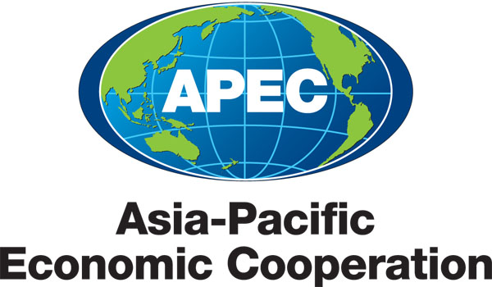
___________________________________________________________________________
2010/SOM3/SCE/021
Agenda Item:6.2

CTTF Independent Assessment: Recommendations to SCE and SCE Decisions

Purpose: Information

Submitted by: APEC Secretariat

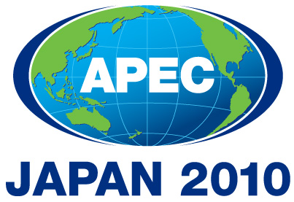 | Third SOM Steering Committee on Economic and Technical Cooperation Meeting  Sendai, Japan  24 September 2010

INDEPENDENT ASSESSEMENT OF THE COUNTER – TERRORISM TASK FORCE (CTTF):

RECOMMENDATIONS TO SCE AND SCE DECISIONS

Recommendations by  Independent Assessor | Comments from member economies and/or APEC Secretariat | Suggested Action to be taken by SCE or CTTF | Proposed timeline to implement the recommendation by SCE or CTTF | Agreement on the suggested action  (Yes/No)
Recommendation to SCE1.  Outlining its key expectations and requirements for the coming year in a generic letter to each Chair/Lead Shepherd inviting them to attend the SCE-COW session at the first SOM as an opportunity for collegial discussion leading to consensus on any final adjustments | Member economies  - Support the recommendation; ways to improve attendance and the efficiency of SCE-COW be assessed (including the feasibility of holding of all initial working group/task force meetings at the margins of SOM1).  - We strongly agree with this recommendation and would like to see it implemented if this is not the practice already.  APEC Secretariat  All Chairs/Lead Shepherds of WG/TF are invited to annual SCE-COW. The attendance level at this meeting has not been very high over the past few years. The SCE Chair regularly writes to Chairs/lead shepherds: before SCE-COW to invite them to the meeting and outlines key issues for discussion at the meeting; after each meeting to inform them of the new development and key decisions of SCE/SOM relevant to their work. | SCE to take into consideration the recommendation in its work to improve the efficiency and effectiveness of SCE-COW. | SCE3 2010 | Yes
Recommendation to SCE2.  In consultation with the CTI, identifying the CTI and SCE sub-fora with the lead responsibility for each cross-cutting initiative which has a human security dimension; and requiring these responsibilities to be reflected in their Terms of Reference and Work Plans. | Member economies  - Support the recommendation to leverage cross-linkages amongst the "human security" agenda in APEC, and examine further ways to increase collaboration in this field (cross-fora strategic plans + joint "human security" sessions).  - We agree. After consulting with various agencies in our economy that are involved in APEC's fora dealing with cross-cutting human security issues, the common theme to emerge in feedback that we received was that there was a concern that the CTTF was actually in danger of duplicating work already being done elsewhere and the need to minimise duplication of effort across APEC. Clearly identifying which fora has the lead on certain counter terrorism initiatives and work streams and reflecting this in their terms of reference would go some way to alleviating this concern. | SCE to discuss this recommendation at SCE3 in conjunction with the discussion on HWG independent assessment recommendations. | CSOM 2010 | Yes
Recommendation to SCE3.  Through its Friends of the Chair Group on Accountability and Communications, identifying an efficient way to convert relevant findings and recommendations contained in independent assessment reports into useful guidance for sub-fora to follow in strengthening their management frameworks | Member economies  - This is a useful suggestion and we believe that this is already happening through the revision of guidelines for lead shepherds that the FOTC is currently working on.  - Welcome this recommendation. | No action required – SCE already implemented through the revision of Guidelines for chairs/lead shepherds. |  | Yes
Recommendation to SCE4.  Notifying the CTTF on any high-level policy or management issues that it should address in preparing the case for a fourth renewal of its mandate in 2010 | Member economies  - We feel that the CTTF should try and address most, if not all, of the management-related recommendations in the report for the CTTF's consideration (i.e. CTTF2 through to CTTF24). The three most important being CTTF3 (Strengthening/tightening the Group's Terms of Reference) CTTF23 (development of a medium term strategy) and CTTF24 (appointment of a Vice Chair to support the Chair).  - Welcome this recommendation.  - It is the responsibility of sub-fora to justify their existence | No action required. |  | Yes
Recommendation to SCE5.  Through its Friends of the Chair Group on Accountability and Communications, (a) identifying the extent to which the CTTF, other small sub-fora and the Experts Groups of larger sub-fora are presently operating in the human security field with similar or partially overlapping mandates; (b) assessing the practicality of consolidating their medium term strategies into a single document; and (c) actively encouraging these sub- fora and their experts groups to find affordable opportunities for increased cross-participation and collaboration | Member economies  - Although we agree that the feasibility of having an APEC-wide strategy or "single document" for Counter Terrorism (e.g. by studying the existing medium term strategies of human security related fora) should be investigated we wonder whether the SCE FOTC is the right body to do this. We think that one of the conditions for the renewal of the CTTF's mandate this year should be that it once again refocuses on its coordinating role for APEC's CT efforts and that the CTTF is tasked with consulting/working with other relevant fora in developing an APEC-wide counter terrorism strategy. The findings of recommendation SCE2 should feed into this process and this APEC-wide strategy should clearly identify which APEC fora has the lead in implementing various aspects of the strategy. The APEC New Strategy for Structural Reform (ANSSR) is a good example of an APEC-wide strategy (for Structural Reform) that clearly articulates which part of the APEC structure (e.g. the Economic Committee or the HRDWG) is responsible for implementing various aspects of the strategy.  - Support this recommendation to leverage cross-linkages amongst the "human security" agenda in APEC, and examine further ways to increase collaboration in this field (cross-fora strategic plans + joint "human security" sessions). | SCE to take note of this recommendation in its effort to improve coordination among fora and during discussion of the HWG independent assessment recommendations. | SCE3 2010 | Yes

