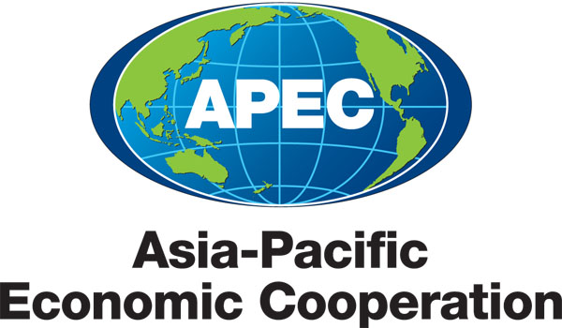
___________________________________________________________________________
2010/SOM3/SCE/022
Agenda Item:6.3

CTTF: Review of Mandate

Purpose: Consideration

Submitted by: CTTF Chair

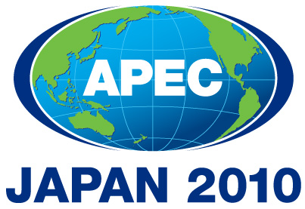 | Third SOM Steering Committee on Economic and Technical Cooperation Meeting  Sendai, Japan  24 September 2010

COUNTER-TERRORISM TASK FORCE (CTTF): REVIEW OF MANDATE

Introduction

APEC member economies recognize that creating a secure environment for economic activity is a vital part of any strategy for regional growth and prosperity. Since 2001, APEC has played a valuable and constructive role in helping to protect the economic systems of the Asia-Pacific region from attack, disruption, and misuse as an important component for a safer business environment. This includes efforts to mitigate risks to transportation, the supply chain, and the financial system, without compromising the flow of legitimate trade and travel.

Since its establishment in 2003, the mission of the CTTF has been to:
- Coordinate the implementation of the Leaders’ and Ministers’ commitments and instructions on counter-terrorism and secure trade, using the APEC Counter-Terrorism Action Plan (CTAP) as the foundation for this work;
- Assist economies to identify and assess counter-terrorism and secure trade needs.
- Sponsor and coordinate capacity building and technical assistance programs to enhance APEC members’ capabilities to counter terrorism and secure trade, including through appropriate consultation with the private sector, international financial institutions and other international organizations;
- Facilitate close coordination and cooperation among relevant APEC fora on counter-terrorism and secure trade issues, and assist in making recommendations on proposals and projects to APEC Senior Officials;
- Cooperate with the relevant international organizations to advance the implementation of Leaders' and Ministers' instructions and avoid unnecessary duplication of efforts.

On the expiry of the CTTF’s mandate at the end of 2010, CTTF members agreed to request Senior Officials to renew the CTTF mandate to allow the task force to monitor progress and build capacity in counter-terrorism.

This paper reviews developments to date and makes recommendations for the SOM Steering Committee on ECOTECH (SCE) and Senior Officials consideration at the SOM 3 2010 meeting in Sendai, Japan.

Instructions from Leaders and Ministers in 2009

APEC Leaders and Ministers reaffirmed in September 2009 the importance of enhancing human security and reducing the threat of disruptions to business and trade in sustaining economic growth and prosperity in the Asia-Pacific region and commended the active role that the CTTF has continued to play to improve the environment for safer trade and investment in the region.

Specifically, Leaders stated “We recognise the importance of building capacity to counter terrorism and welcome APEC's work in areas such as trade security, aviation security, anti-terrorist protection of energy infrastructure, countering terrorism financing, fighting cyber-terrorism, protecting the food supply against terrorist contamination and emergency preparedness.”

Ministers declared “We reaffirm the importance of our initiatives in areas such as trade security, port and aviation security, anti-terrorist protection of energy and information infrastructure, countering terrorism financing, and protecting the food supply from terrorist contamination, and in this regard encourage all economies to update their Counter Terrorism Action Plans (CTAPs), which will provide useful information for identifying capacity building needs and prioritising actions accordingly.

We recognise the need for aviation security within the APEC region. We look forward to the upcoming APEC Air Cargo Security Workshop, which will be held in Singapore during the summer of 2010. We commend APEC’s efforts to promote further exchange of best practices and lessons learned in the area of air cargo security, and to explore available technological solutions to the unique challenges of air cargo security.”

Key outcomes of the Task Force

APEC Trade Recovery Programme (TRP) Pilot Exercise

The TRP pilot exercise was conducted in two phases; Phase 1 (10-24 April, 2009) and Phase 2 (28-30 April 2009). The pilot exercise reaffirmed the relevance of the APEC TRP Guidelines developed in 2007 and showed that the concept of a risk-based total supply chain security approach can facilitate trade recovery by indentifying high risk shipments at an early stage, and facilitate the movement of low risk shipments.

Seventh Secure Trade in the APEC Region (STAR VII) Conference

The theme of the conference was "Enhancing Trade Security and Economic Resilience" and separate sessions covered the following five topics: Security threats to the global economy; Towards trade security, resilience and effective trade recovery; An integrated approach to secure trade; Building trust and transparency; and Towards trade security, resilience and effective trade recovery.

Air Cargo Security Workshop

This joint project between the Transportation Working Group’s Aviation Security Experts Group (TPTWG/AEG-SEC) and CTTF promoted the further exchange of best practices and lessons learned in the area of air cargo security, facilitated the establishment of capacity building relationship between donor economies and those economies seeking to establish or improve air cargo security, and explored available technological solutions to the unique challenges of air cargo security.

Seminar on Securing Trade through Counter-Terrorism Efforts

The seminar promoted secure trade through counter-terrorism measures by facilitating the exchange and sharing of experience and lessons learned in the areas of maritime and port security.

Workshop on Improving Regulation of the Non-Profit Organisation Sector

The workshop built the capacity of regional governments to establish effective regulatory systems relating to the NPO sector and strengthened regional counter-terrorism and anti-money laundering linkages in the Asia Pacific.

The Second Workshop on Detecting and Deterring Cash Couriers and Bulk Cash Smugglers

The workshop enhanced the capacity and effectiveness of government agencies to detect and prevent terrorist financing activities through collaborative identification of key issues and strategies, through the strengthening of regional linkages, relationships and cooperation among agencies involved in counter-terrorism, and by ensuring more effective implementation of international anti-money laundering/counter terrorist financing recommendations set by the Financial Action Task Force.

The Second Seminar on Protection of Cyberspace from Terrorist Use and Attacks

The Seminar addressed various cyber security issues, including the protection of critical infrastructure, and contributed to the exchange of best practices and experiences in fostering a culture of cyber-security and encouraged cooperative and effective efforts in the region to combat diverse cyber-threats and cyber-terrorism.

The Second Food Defense Pilot Project with Thailand: Putting Principles into Practice

The project is under implementation. This pilot project is focusing on three key areas: engendering food defense awareness among stakeholders; encouraging close communication and collaboration on food defense issues between stakeholders; and developing, through private-to-private partnerships, food defense plans for individual companies. The experiences and lessons learned from the pilot project will be captured and used to create a case study example that will be shared with all APEC members.

Revision of Counter-Terrorism Action Plan (CTAP)

The revised template streamlined the existing template, focused responses and reduced the workload of those completing the CTAP.

Future challenges for APEC and the CTTF

The concerted efforts by the APEC economies to counter terrorism threats have yielded results. However, terrorism continues to pose serious challenges to APEC’s vision of free, open, and prosperous economies.

The CTTF recognizes that APEC’s work on counter-terrorism and secure trade are spread out across a number of APEC fora, and that the CTTF can make a critical contribution to APEC’s trade and investment, human security and secure growth agendas by facilitating enhanced cooperation and coordination among these groups.

As elaborated in the Medium Term Work Plan the CTTF submitted to the SCE, the CTTF intends to make capacity building and technical cooperation its top focus to help economies to better address terrorist threats and advance implementation of Leaders’ and Ministers’ commitments. The CTTF also seeks to enhance consultation and cooperation among relevant APEC fora a top priority, and to improve its effectiveness in this regard.

For this reason, it is proposed that the CTTF maintains its role as a coordinating body, which undertakes work through its meetings on the margins of Senior Official’s Meetings and intersessionally via electronic communications – as provided for in its terms of reference, and renews its mandate for 2011-2012.

CTTF recommendations for SCE

To respond to Leaders and Ministers instructions and to meet new challenges in APEC’s counter-terrorism agenda, the CTTF recommends that SCE:
- endorse the extension of the CTTF mandate for a further 2 years;
- forward to SOM the request to grant the renewal of the mandate

