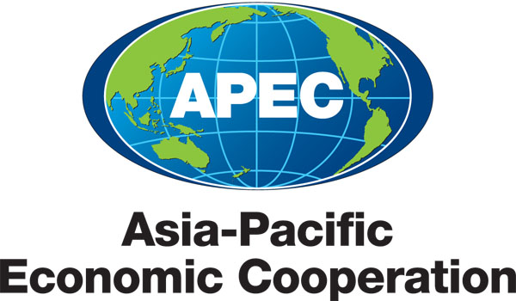
___________________________________________________________________________
2010/SOM3/SCE/025
Agenda Item: 8.1

ATCWG Terms of Reference

Purpose: Consideration

Submitted by: ATCWG Lead Shepherd

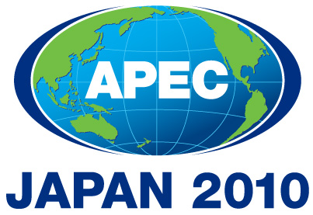 | Third SOM Steering Committee on Economic and Technical Cooperation Meeting  Sendai, Japan  24 September 2010

ASIA-PACIFIC ECONOMIC COOPERATION
AGRICULTURAL TECHNICAL COOPERATION WORKING GROUP

TERMS OF REFERENCE

Article 1 Establishment of the APEC Working Group on Agricultural Technical Cooperation (ATC)

The previous APEC Experts Meeting on ATC was established as an Experts Group on Agricultural Technical Cooperation in November 1996. The Group was renamed to the Agricultural Technical Cooperation Working Group in November 2000.

Article 2 Objectives

The Group will serve as a forum for member economies to enhance the capacity of agriculture and its related industries to contribute to economic growth, food security and social well-being in the region.

Article 3 Principles of Cooperation

The activities of the Group will accord with the principles and essential elements of Economic and Technical Cooperation set out in Part II of the Osaka Action Agenda (updated in 2001) and with any subsequent directions from APEC Economic Leaders, Ministers and Senior Officials. These activities will:

- be based on the principles of mutual respect and equality, mutual benefit and assistance, constructive and genuine partnership and consensus building;

- develop an environment favourable to the effective operation of market mechanisms and integrate into the cooperation process the business/private sector and other pertinent institutions where possible;

- integrate environmental considerations in all relevant activities, and take into account the essential elements of Common Policy Concepts, Joint Activities and Policy Dialogue, while respecting the autonomy of each APEC economy over its policies.

In addition, agricultural technical cooperation will:

- pay due consideration to the diversity of agricultural sectors in the region;

- recognize the rapid changes occurring in the agricultural sectors in the region; and

- avoid duplication with, and add value to, other APEC activities, and activities undertaken by international agencies and regional fora.

Article 4 Scope of Activity

  - The Group will carry out its activities consistent with the vision statement and action plans incorporated in the Osaka Action Agenda and any subsequent directions, including those to be identified by the first Ministerial Meeting on Food Security in Niigata on October 2010.

  - The Group will concentrate in its future work on developing a dialogue and implementing agreed action programs on economic and technical cooperation along the chain of agriculture and food production, processing, marketing and distribution with special emphasis on opportunities for agricultural technical cooperation.

  - The work of the Group shall proceed in parallel with, and complement the work of other APEC groups.

  - Agricultural Technical Cooperation will focus on, but not be limited to, the following areas of activities:

- Promote activities and regional cooperation to strengthen food security in the APEC region

- Conservation and Utilization of Plant and Animal Genetic Resources

- Research, Development and Extension of Agricultural Biotechnology

- Production, Processing, Marketing, Distribution and Consumption of Agricultural Products

- Sanitary and phyto-sanitary (SPS), Integrated pest management (IPM), Biosecurity, Biodiversity, and control of invasive alien species (AIS).

- Cooperative Development of Agricultural Finance System

- Sustainable Agriculture and Related Environmental Issues, including climate change adaptation and mitigation.

- Agricultural investments and trade facilitation

  - Above mentioned areas of activities will be reviewed annually against their objectives.

  - Where appropriate, the Group will liaise with the business sector and relevant regional and international bodies to ensure that its work is relevant, practical and focused and to avoid duplication.

Article 5 Structure of the Group

5.1 The Group will be composed of officials and experts from universities, public and private sectors. There shall be a rotation of the Lead Shepherd every two years.

5.2 The Group will have a Lead Shepherd and a Deputy Lead Shepherd for ATCWG, which is appointed by consensus within the Group.

5.3 The Group will meet at least annually, with meetings arranged in such a way which minimizes resource costs and maximizes member participation.

5.4 The Group may establish special task forces with strictly defined terms of reference and duration.

5.5 The Group shall review the scope of its activities and all aspects of its operations every three years or as new issues appear. In addition, as part of the recommendation 12 of the SCE Fora Review, the ATCWG will be independently assessed every four years according to the Independent Assessment Schedule endorsed by the SCE.

5.6 The Group will report annually through the SCE Fora Report or as requested by SOM.

End

