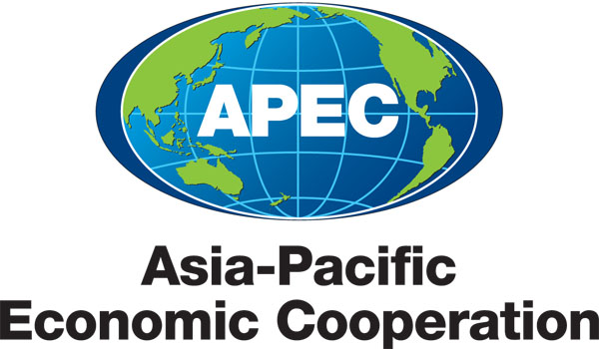
___________________________________________________________________________
2010/SOM3/SCE/026rev1
Agenda Item: 8.2

U.S.-Japan Cooperation on Emergency Preparedness

Purpose: Information

Submitted by: Japan & United States

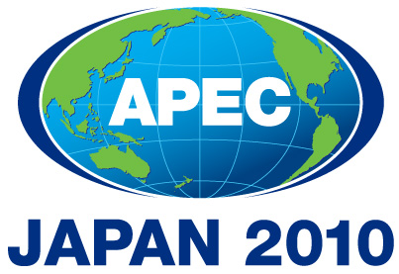 | Third SOM Steering Committee on Economic and Technical Cooperation Meeting  Sendai, Japan  24 September 2010

EMERGENCY PREPAREDNESS IN APEC
(United States – Japan Proposal)

BACKGROUND
The Asia-Pacific is the world’s most disaster prone region, having suffered about 40% of disasters and accounting for 92% of disaster victims worldwide from 2000 to 2006. In 2008, disaster-related damage totaled more than 190 billion USD worldwide and 118 billion USD in Asia alone. Natural disasters cost developing economies, on average, 2-15% of GDP annually. Effective disaster management cannot be realized by governments alone. APEC, through its strong networks with the business sector, has a comparative advantage in encouraging greater private sector participation in emergency preparedness and risk reduction, including by promoting public-private partnerships and building disaster-resilient businesses. With the spread of globalization, disasters that affect one member economy can have significant spill-over effects in other economies. Building businesses that are resilient to disasters is essential for ensuring the continuity of business, trade, and economic growth as well as safeguarding both employment and regional supply-chains following disasters.

UNITED STATES – JAPAN COOPERATION
On 29 March 2010 in Ottawa, the United States and Japan, as the hosts of the APEC forum in 2010 and 2011, issued a press statement on joint cooperation on APEC, which called for bilateral work on several signature initiatives to support broader APEC outcomes including enhanced cooperation in emergency preparedness, with a focus on public-private partnerships and networking among experts.

At the 4th APEC Senior Disaster Management Officials Forum in Kobe in January 2010, it was recommended that: 1) fostering public-private partnerships should be a top priority; and 2) networking among emergency management authorities should be strengthened. Based on those recommendations the United States and Japan will work together with other economies to add value to regional emergency management efforts, through, among others, the following:

Fostering APEC Private-Public Partnerships
We welcome the outcomes of the Public-Private Partnerships and Disaster Resilience Workshop held in Thailand August 24 – 27 and will look to build on those efforts at the Fifth Senior Disaster Management Officials Forum in 2011. To ensure the continuity of business, trade, and economic growth in the event of an emergency, it is imperative to promote Business Continuity Planning (BCP) at all levels. Thus, the U.S. and Japan will propose a joint workshop in 2011 to support private sector preparedness.

Strengthening Emergency Management Networking in the APEC region
The U.S. and Japan have partnered to strengthen networking among emergency management experts to support business and community resilience. Recently, the U.S. sent experts from its Federal Emergency Management Agency (FEMA) to meet with Japanese officials to share challenges, solutions and best practices related to community preparedness and participation, hazard mitigation and economic and community recovery and to observe the National Disaster Prevention Day awareness-raising events and drills held on September 1st.

The U.S. and Japan will continue to cooperate with other APEC economies to:
- improve the effectiveness and content of the Emergency Preparedness Working Group’s website
- identify gaps in regional disaster risk reduction approaches, and
- develop a suite of practical mechanisms to support business and community resilience in APEC economies.

