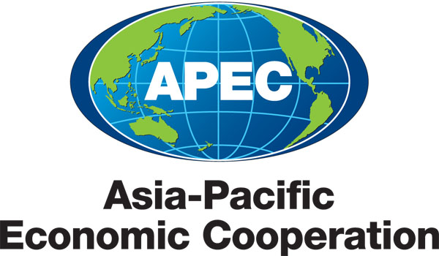
___________________________________________________________________________
2010/SOM3/SCE/028
Agenda Item: 3.5

HWG Medium Term Workplan (2010 – 2015)

Purpose: Consideration

Submitted by: HWG Chair

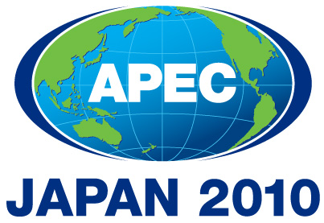 | Third SOM Steering Committee on Economic and Technical Cooperation Meeting  Sendai, Japan  24 September 2010

MEDIUM TERM WORKPLAN
(2010 – 2015)
Name of the Group: Health Working Group

- MEDIUM-TERM GOALS (please provide some explanation/description of the medium term goals that the group will work toward in order to facilitate achievement of APEC-wide strategic objectives )

The Health Working Group will continue to identify opportunities to improve health security and prosperity in the region and make a critical contribution to APEC’s human security and inclusive and secure growth agenda. In order to achieve this, the HWG should take a leadership and coordinating role, as the expert group on health issues in APEC. Any activities that will be carried out through the HWG should continue to relate to APEC core areas, particularly economic and technical cooperation.
The Health Working Group could consider the following recommended areas of engagement:
- To further examine and address the links between health, trade and economic development and cooperation.
- To continue to strengthen APEC member economies capacity to respond to public health emergencies and emerging public health issues.
- To commit to broader and longer-term multi-sectoral cooperation and coordination between health experts and other sectoral experts.
The HWG should focus on a limited number of areas which could produce tangible results under the two-year terms of the Chair, as well as respond to specific Leaders directives. As a Working Group, it will be important to continue to identify areas of cooperation and capacity building that can be achieved, or substantially initiated, within this timeframe to ensure continued productivity and relevance of the HWG’s workplan.
The APEC Health Ministers recommended in June 2007 that future work in APEC builds from the immediate emergency management of current health threats to maintaining systems and strategies that will be able to respond, while ensuring that we continue to invest and build our technical and structural responses to address future threats to health security.
The HWG will focus its attention on three priority areas.
Priority 1 - Enhancing preparedness for and effective management of emerging and re-emerging infectious diseases, vector-borne diseases, HIV/AIDS and pandemics.
In 2009, Leaders reaffirmed their commitment to build regional capacity for avian and other potential human influenza pandemics and emerging and re-emerging infectious diseases such as HIV/AIDS. Based on the results of the “HTF Report on the Implementation of the APEC Action Plan on the Prevention and Response to Avian and Influenza Pandemics”, the HWG will continue to work on key elements of the Plan. Priority areas that have been identified are:
- continuity of business and essential services through a deepened engagement of the private sector remains a key priority for ongoing work. This is an area that has been identified as critical to maintaining economic and social stability during a pandemic and other health emergencies;
- the momentum behind the multi-sectoral cooperation and collaboration must be maintained;
- the need for coordinated, consistent and culturally relevant risk communication approaches and information has been highlighted;
- address agriculture and trade issues through enhanced collaboration with other APEC fora, particularly with the Agriculture Technical Cooperation Working Group and APEC Business Advisory Council;
- coordinated regional response to avian and human pandemic influenza by developing consistent approaches with international and regional organizations and civil society groups and ensuring non-duplication of efforts, is seen as important to ensuring an effective response.
APEC Ministers and Leaders have noted with concern the spread of HIV/AIDS. Leaders and Ministers recognized that a multi-sectoral approach is required and called for enhanced cooperation within APEC and movement towards the goal of universal access to HIV/AIDS prevention, treatment, care and support
Priority 2 - Building capacity for the prevention of non-communicable diseases including injuries.
- Non-communicable diseases, especially lifestyle-related diseases such as obesity and diabetes, are issues of increasing concern not only in developed economies but also in developing economies. The prevalence of non-communicable disease is increasing as a critical concern in close relationship to rising economic growth.
- As a healthy population/workforce is a key factor in economic growth, efforts in health promotion, effecting healthy lifestyle changes and raising the awareness of the causes and means for preventing NCDs are essential.
Priority 3 - Strengthening health systems of economies including health financing, human resources and health information technologies which would contribute to inclusive and secure growth.
- Strengthening health systems contributes to economic stability and sound economic growth. Considering the development of health systems as an investment for the future, maintaining essential services and fair access and establishing quality and effective health services ensures a healthy population and therefore a productive labour force. This includes developing system to integrate acute care and step-down care services in order to ensure that patients have access to affordable and appropriate levels care and are able to transit seamlessly from one healthcare setting to another.
- Information technology has great potential to efficiently enhance progress on health care. Investment in health information technology would contribute to addressing health and related economic challenges facing the region.
- The importance of strengthening health systems was also recognized in the APEC Leaders’ Meeting Statement in 2009. Platforms to discuss health challenges and foster consensus building and partnerships among key policy makers would be encouraged.
Other potential areas which have only begun to be addressed, and where there is merit to continue this work in APEC might include:
- broader and longer-term coordination, especially between animal and human health experts, to reduce the risk of the emergence of other zoonotic diseases;
- where applicable, improving awareness of and capacity to implement international regulations and recommendations, as outlined in the APEC Health Ministers' Statement, 2007;
- improving awareness of and capacity to implement international regulations and recommendations, such as the International Health Regulations, as outlined in the APEC Health Ministers Statement, 2007;
- improving cooperation and capacity of economies to promote international trade and the continued movement of people and goods, as appropriate, in the event of a health emergency;
- business continuity and the maintenance of basic infrastructure and services during a public health emergency;
- enhancing human resources and information communication related to health emergencies;
- building a regular communication network mechanism for exchanging up-to-date information on health-related issues;
- building our current infrastructure to address all events that could threaten health security (APEC HMM Statement);
- strengthening public health capacity and healthcare systems: Members could collaborate to strengthen regional and domestic capacities for public health surveillance and response as well as epidemic preparedness in an effort to minimise morbidity, mortality and economic loss;
- assessing the economic impacts of non-communicable chronic diseases/lifestyle diseases, as appropriate;
- examining the links between health, the environment and economic development by examining the economic impact of emerging and re-emerging zoonotic diseases, pollution and water quality as a result of changes in the environment.
The HWG will also function as a gateway to technical experts and also as a central policy “think tank”, which will focus on inter-sectoral policy coherence and communications. An initial broad goal is to enhance and strengthen networking for a better response to regional health threats, including sharing relevant information in an effective and timely manner. In order to put this into effect, the HWG proposes to hold a policy dialogue with other APEC fora to discuss priority issues from their perspectives at one of the HWG meetings each year.

- WORK PROGRAM

goals/objectives (please indicate the ecotech priority workstream that they support) |  | Action items/Specific processes/activities |  | Expected Outcomes |  | Timeframe |  | Cooperating party (mo/other apec fora)
1．Enhancing preparedness for and effective management of emerging and re-emerging infectious diseases, vector-borne diseases, HIV/AIDS and pandemics |  | - HWG’s Projects, which would enhance preparedness and management of emerging and re-emerging diseases, are selected to be implemented and monitored. |  | Build regional capacity for emerging and re-emerging infectious diseases, vector-borne diseases, HIV/AIDS and pandemics |  | 2010-2015 |  | WPRO& SEARO/WHO, ASEAN
2．Building capacity for the prevention of non-communicable diseases including injuries |  | - HWG’s Projects, which would build capacity for the prevention of non-communicable disease, are selected to be implemented and monitored. |  | Identification of new capacity building activities that will lead to prevention of non-communicable diseases including injuries |  | 2010-2015 |  | WPRO&SEARO/WHO, ASEAN
3. Strengthening health systems of economies including health financing, human resources and health information technologies which would contribute to inclusive and secure growth |  | - HWG’s Projects, which would strengthen health systems of region economies, are selected to be implemented and monitored.  - The HWG will work closely with other APEC fora, especially with the Life Science Innovation Forum (LSIF). |  | Identification of new activities that will contribute to strengthen health systems in the region |  | 2010-2015 |  | WPRO&SEARO/WHO, ASEAN  LSIF,  Private sector, Academia

