

**Seminar Standards 2011: Standards Towards Increasing Market Competitiveness**

13 December 2011

Nilam Hall, MITI

**OBJECTIVES**

* Enhance the awareness of industry on standardisation activities including mandatory standards compliance, accreditation and social responsibility; and
* Platform of knowledge sharing between the industries and government agencies.



Y. Bhg. Datuk Dr. Rebecca Fatima Sta Maria

Secretary General

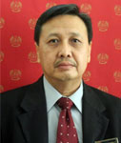

Y. Bhg. Dato’ Nik Rahmat Nik Taib

Deputy Secretary General (Industry)

**PROGRAMME**

|  |  |
| --- | --- |
| **Agenda** | **Time** |
| ***Registration*** | ***8.30 am – 9.00 am*** |
| ***Opening***  ***Pn. Harjit Kaur***  ***Senior Director, Investment Policy and Trade Facilitation Division*** | ***9.00 am – 9.10 am*** |
| ***Ministry of Science, Technology and Innovation (MOSTI)***  ***Policy on Standards and Way Forward*** | ***9.10 am – 9.30 am*** |
| ***STANDARDS MALAYSIA***  ***Accreditation activities in Malaysia*** | ***9.30 am – 9.50 am*** |
| ***Coffee Break*** | ***9.50 am – 10.20 am*** |
| ***SIRIM***  ***Overview of ISO 26000 Social Responsibility and the benefits to industries.*** | ***10.20 am –10.40 am*** |
| ***MITI***  ***The importance and benefits of adopting standards*** | ***10.40 am –11.00 am*** |
| ***TNB Research Sdn Bhd***  ***Success stories of implementing and complying with international standards*** | ***11.00 am –11.20 am*** |
| ***Hume Cemboard Industries Sdn Bhd***  ***Success stories of implementing and complying with international standards*** | ***11.20 am –11.40 am*** |
| ***Q&A / Discussion Session with Industries***  ***Moderator : Haji Amran Hj. Sameon***  ***Theme :Standards Towards Increasing Market Competitiveness***  ***Topic : Impact of Standards to Malaysia’s Industries***   * + - * ***Feedback from Industries***       * ***Recommendations to the Government*** | ***11.40 am –12.40 pm*** |
| ***Closing***  ***Y. Bhg. Dato’ Nik Rahmat Nik Taib***  ***Deputy Secretary General (Industry)*** | ***12.40 pm- 1.00 pm*** |
| ***Lunch*** | ***1.00 pm – 2.00 pm*** |

**Speaker**

Mr. Mohd. Khairul Adib Abd. Rahman is the Deputy Undersecretary for Industrial Technology Division since August 2011. He pursues his master’s degree in Policy Science at Saitama University. His initial portfolio at MOSTE covers public and private sectors R&D funding and at the later stage, involved immensely in the issues of environment. After serving 7 years at MOSTI, he was appointed Counsellor at the Malaysian Embassy in Tokyo and later on to the Malaysian High Commission in London. He came back in 2009 to Ministry of Science, Technology and Innovation (MOSTI) where he held the position of Head of Strategic before joining Industrial Technology Division MOSTI in August 2011.

**Speaker**

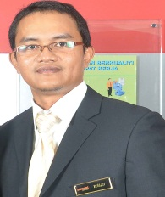

Mr. Roslan Alias is a Senior Principal Assistant Director of Accreditation in the Department of Standards Malaysia (STANDARDS MALAYSIA). His nature of work includes assisting Director of Accreditation in the implementation of MIBAS & SAMM scheme. He received his Bachelor of Science with Honor in Chemical Engineering from University Technology Malaysia (UTM).

**Speaker**

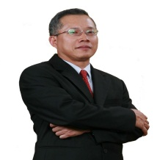

Hj. Ab. Razak bin Salim has more than 30 years working experience and currently work as Advisor in the President Office SIRIM Berhad. He graduated from University of Malaya with a Bachelor in Accounting (Honors) and Master in Business Administration from University of Wales Cardiff. He is also a member of Malaysia Institute of Accountant. He has been involved in the development of ISO 26000 since 2005 and chaired the National Mirror Committee in 2009 during the development of the International Standard. Currently he chairs the Technical Committee for the development of SR standard for Malaysia.

**Speaker**

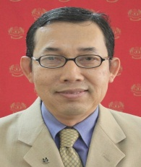

Haji Amran Hj. Sameon is the Director of Trade Facilitation and Technology Section, MITI. He holds a degree in economics with Honors from Science University of Malaysia and obtained his Masters in Business Administration from University of Ohio, Athens, Ohio, USA. He was formally the Director for the Industrial Services, MITI and the Director for Investment and Industrial Policy before holding the current position.

**Speaker**

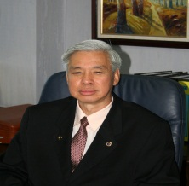

Dr. Ir. Cheong Kam Hoong is the Managing Director of TNB Research Sdn. Bhd. He received his Bachelor of Science in Electrical Engineering (BSEE) with High Honor from Ohio University, Athens, USA, while his Ph.D. degree from the Dept. of Industrial Information & Control Systems, Royal Institute of Technology, Stockholm, Sweden. With professional qualifications and wide industry experience, Dr. Ir. Cheong Kam Hoong has also contributed to a number of publications since 1996.

**Speaker**



Dr. Ang Show Hing is the R&D Head of Hume Cemboard Industries Sdn. Bhd., a Cellulose Fibre Reinforced Cement board manufacturing company. Her areas of interest are in Materials and product applications research and development. In 1995, she obtained her Bachelor of Applied Science (Industrial Chemistry), and later Doctor of Philosophy (Ph.D) in Inorganic Chemistry in 1999.

**Secretariat**

1. **Mr. Mohamad Farid Mohd Aris – Principal Assistant Director, Standards and Environment Unit.**
2. **Ms. Naztassia Yusop – Assistant Director, Standards and Environment Unit.**
3. **Ms. Samala Santhappan - Assistant Director, Standards and Environment Unit.**
4. **Ms. Juriza Redzwan – Assistant Director, Innovation and Technology Unit.**
5. **Ms. Noorshafina Ismail – Standards and Environment Unit.**

**-Thank you-**

For any enquiries, please call:

Investment Policy and Trade Facilitation Division  
Ministry of International Trade and Industry  
Level 10, Block 10,   
Government Offices Complex, Jalan Duta,  
50622 KUALA LUMPUR

Ms. Naztassia Yusop  
Tel: 03-6203 1246  
Fax: 03-6201 2339  
E-mail: [naztassia.yusop@miti.gov.my](mailto:naztassia.yusop@miti.gov.my)